Task 2.1: Updated STA-1W Cell 5 Hydraulic Analysis

Science and Technology Service (STS)
Contract No. ST060589-WO01

South Florida Water Management District

June 2, 2006




Prepared by: | Prepared for:
Sutron Corporation | South Florida Water Management District
Hydrologic Services Division (HSD) | Attn: Tracey Piccone, Project Manager
6903 Vista Parkway N, Suite 5 | B-2 Building, 3rd Floor
West Palm Beach, FL 33411 | 3301 Gun Club Road
Tel: (561)-697-8151 | West Palm Beach, FL 32406

Table of Contents

1. Introduction 5
2. Background 7
3. Objective 8
4. Updated Model Setup 8
5. Hydraulic Analyses with the Updated Cell 5 Model 14
(1) Base cases 14
(2) Enhanced Alternative 1: 20
(3) Enhanced Alternative 2: 29
6. Sensitivity Analysis 30
6.1 Numerical Errors 31
6.2 Manning’s n Values 31
6.3 Wind Effect 32
6.4 Topographic Enhancement in Cell 5A 35
6.5 Cuts and Gaps in the Vegetation Strips 35
7. Discussion 37
8. Conclusions 37
References 38

List of Figures

Figure 1: Location of STA-1W 6
Figure 2: Schematic of STA-1W (not to scale) 7
Figure 3: Surveyed Crest Elevation of the Degraded Limerock Berm 9
Figure 4: Topographic Survey Points at the Old Farm Road Locations 10
Figure 5: Surveyed Crest Elevations of the Old Farm Roads 11
Figure 6: STA-1W Cell 5 Topographic Data (elevations lower than 8.0 ft NGVD are not shown) 12
Figure 7: Crest Elevations of the Old Farm Road Segments next the Limerock Berm 13
Figure 8: Water Surface Distribution (1470 cfs, base case) 15
Figure 9: Water Depth Distribution (1470 cfs, base case) 16
Figure 10: Velocity Magnitude Distribution (1,470 cfs, base case) 16
Figure 11: Water Surface Distribution (600 cfs, base case) 17
Figure 12: Water Depth Distribution (600 cfs, base case) 18
Figure 13: Velocity Magnitude Distribution (600 cfs, base case) 18
Figure 14: Water Surface Distribution (300 cfs, base case) 19
Figure 15: Water Depth Distribution (300 cfs, base case) 20
Figure 16: Velocity Magnitude Distribution (300 cfs, base case) 20
Figure 17: Changes in Water Depth Distribution (1,470 cfs, vegetation strips, no fill – base case) 21
Figure 18: Location of Transect A-A’ 22
Figure 19: Transect (A-A’) Water Surface Profiles (1,470 cfs, enhanced and base case) 22
Figure 20: Changes in Velocity Magnitude Distribution (1,470 cfs, vegetation strips and no fill – base case) 23
Figure 21: Changes in Water Depth Distribution (600 cfs, vegetation strips, no fill – base case) 24
Figure 22: Transect Water Surface Profiles (A-A’) (600 cfs, enhanced and base cases) 24
Figure 23: Changes in Velocity Magnitude Distribution (600 cfs, vegetation strips, no fill – base case) 25
Figure 24: Changes in Water Depth Distribution (300 cfs, vegetation strips, no fill – base case) 26
Figure 25: Changes in Velocity Magnitude Distribution (300 cfs, vegetation strips, no fill – base case) 26
Figure 26: Velocity Magnitude Profiles along Transect A-A’ (vegetation strips without fill vs. base case) 27
Figure 27: Water Depth Profile along Transect A-A’ (1,470 cfs, vegetation strips without fill) 28
Figure 28: Changes in Velocity Magnitude along a Transect (A-A’) (1,470 cfs) 29
Figure 29: Changes in Computed Water Depth (600 cfs, vegetation strips, filled to 9.75 ft NGVD vs. base case) 30
Figure 30: Changes in Computed Water Levels (600 cfs, after and before vegetation strips, increased n values) 31
Figure 31: Impact of Wind Effect on Water Surface Elevations (1,470 cfs, no vegetation strips) 33
Figure 32: Computed Water Surface Elevations with and without Wind Effect (1,470 cfs, (a) no vegetation strips; (b) vegetation strips, filled to 9.75 cfs) 34
Figure 33: Changes in Water Surface Elevations (after and before Cell 5A topographic enhancement) 35
Figure 34: Difference in Computed Water Depth (600 cfs, vegetation strips with gaps and no gaps) 36

STA-1W Cell 5 Hydraulic Analysis Final Report
STA Hydraulic Analysis Contract ST060589-WO01

1. Introduction

STA-1 West (STA-1W) is a primary component of the Everglades Construction Project mandated by the 1994 Everglades Forever Act (Section 373.4592, Florida Statutes). STA-1W is situated immediately west of the Arthur R. Marshall Loxahatchee National Wildlife Refuge (WCA-1) and south of the West Palm Beach Canal (Figure 1). It receives stormwater runoff from the S-5A Basin in the Everglades Agricultural Area and provides a nominal treatment area of 6,670 acres. STA-1W consists of three flow ways and Cell 5 is the northern flow way of STA-1W (Figure 2).

Two-Dimensional (2-D) hydraulic models have been previously developed for both STA-1W Cell 5 and STA-1W as a whole (Sutron Corp., 2005). The purpose of this current updated hydraulic analysis is to update the Cell 5 2-D hydraulic model using the new topographic data and enhancement features, and to perform 2-D flow simulations of the STA-1W Cell 5 hydraulics to determine the changes to the STA-1W Cell 5 hydraulic performance induced by Cell 5 enhancements.

The previous STA-1W Cell 5 FESWMS 2-D hydraulic model was built to evaluate the hydraulic impact of the limerock berm in Cell 5 (Sutron Corp., 2005). Since then, Cell 5 configuration has been significantly altered. The limerock was scraped and degraded. Several major hurricanes in the past two years have disrupted vegetation in Cell 5B and enhancements are under way for STA-1W Cell 5.

The tasks associated with this current hydraulic analysis effort are described in Task 2 of the scope of work for ST060589-WO01, precisely under Subtask 2.1: Updated STA-1W Cell 5 Hydraulic Analysis and Subtask 2.2: Updated STA-1W Cell 5 Final Report. This report (Deliverable 2.2) summarizes major results obtained in the project work for the Subtask 2.1: updated STA-1W hydraulic analysis.

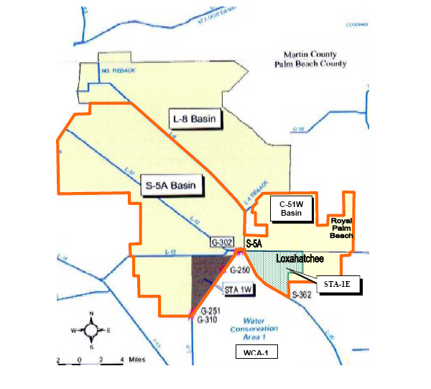
Figure 1: Location of STA-1W
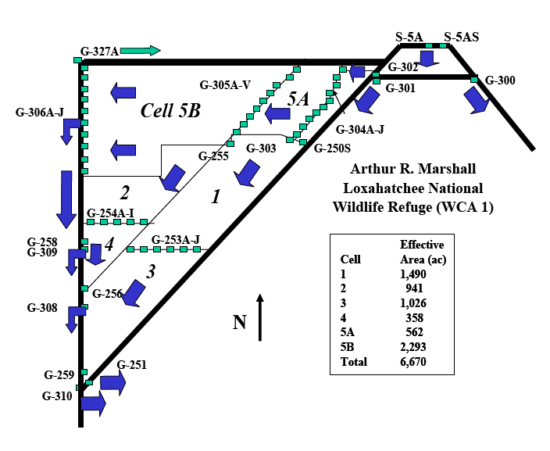
Figure 2: Schematic of STA-1W (not to scale)

2. Background

The vegetation and sediment in Cell 5 were severely disrupted by several major hurricanes in 2004 and 2005 (SFWMD, 2005 and 2006). Cell 5 major performance issues cited include:

- Unconsolidated sediment that causes excessive turbidity and inability in sheltering submerged aquatic vegetation (SAV) roots.
- Uprooted SAV vegetation and re-suspension of sediment into the water column caused by severe hurricane winds.
- Non-uniform, deep water depths in Cell 5A leads to difficulty in growth of emergent vegetation in excessively deep areas.

The District has prepared a plan to address the Cell 5 issues (SFWMD, 2005 and 2006) through a series of new enhancement activities.

The current updated hydraulic analysis is an attempt to quantitatively evaluate the hydraulic effects of the new proposed Cell 5 enhancements.

3. Objective

The objective is to revise the existing STA-1W Cell 5 2-D hydraulic model (Sutron Corp., 2005) and perform updated hydraulic analyses to aid the District in the design of additional enhancements to the treatment cell.

The purpose of the current hydraulic analysis is to answer the question: How will Cell 5 hydraulics be altered by the new enhancements? Specifically, can the 2-D hydraulic model provide quantitative answers in terms of changes in water depth and velocity distribution?

4. Updated Model Setup

Topographic data:

The STA-1W Cell 5 topographic survey data used for the previous Cell 5 models did not contain information on the old farm roads in Cell 5B. As part of the Cell 5 enhancements project, after the drawdown of the cell was completed, the SFWMD contracted with a surveyor to perform a survey of the old farm roads for use in refining the enhancements plan. Therefore, the finite element mesh was revised for the current modeling effort to incorporate the local resolution of the old farm roads obtained from the 2006 surveying effort.

Also subsequent to the previous Cell 5 modeling (Sutron Corp., 2005), the crest of the limerock berm was lowered from the design crest elevation of 11.5 ft to reduce flow obstruction (SFWMD, 2005). The crest elevation of the scraped-down limerock berm was also updated with the new survey data which show that the current crest elevation of the scraped-down limerock berm ranges from 9.5 ft NGVD to 10.5 ft NGVD (Figure 3).

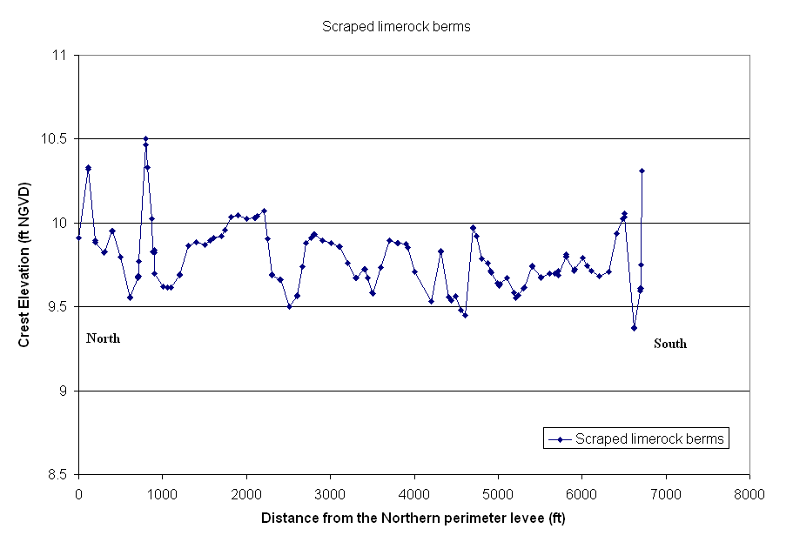
Figure 3: Surveyed Crest Elevation of the Degraded Limerock Berm

There are several old farm roads in Cell 5 (Figure 4). The crest elevation of the old farm roads as determined from the new topographic survey conducted by the SFWMD’s contractor is shown in Figures 5 and 6. The mean elevations of the four old farm roads are: 9.18 ft NGVD, 9.79 ft NGVD (limerock berm), 9.37 ft NGVD and 9.45 ft NGVD, respectively, from west to east. The average ground elevation of Cell 5B is 8.54 ft NGVD. The crest elevations of the old farm roads are not uniform and vary from 8.0 ft NGVD to 10.8 ft NGVD. There are two old farm road segments adjacent to the degraded limerock berm. Their crest elevations are plotted in Figure 7 and compared with the crest elevation of the scraped limerock berm.

A previous tracer project conducted in Cell 5B (DBE, 2004) appears to verify the new survey information completed on the old farms roads. For example, high tracer concentrations occurred behind the local high ground elevations of the old farm roads.

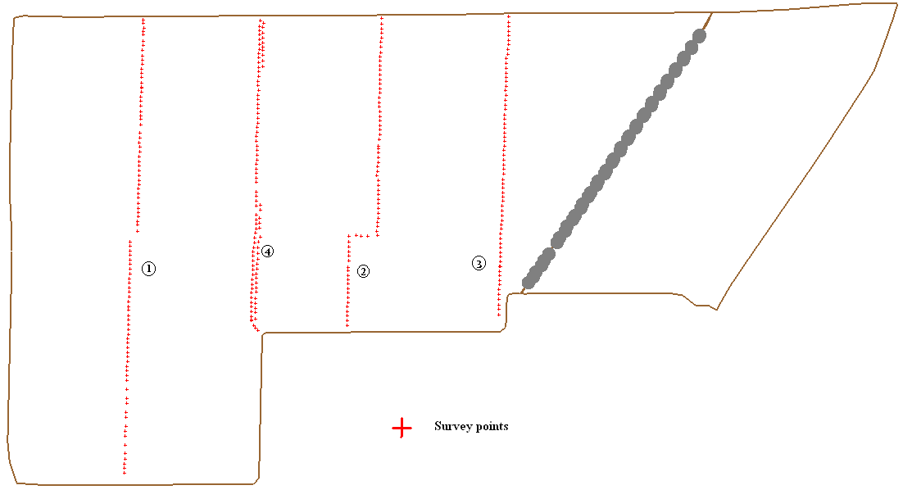
Figure 4: Topographic Survey Points at the Old Farm Road Locations

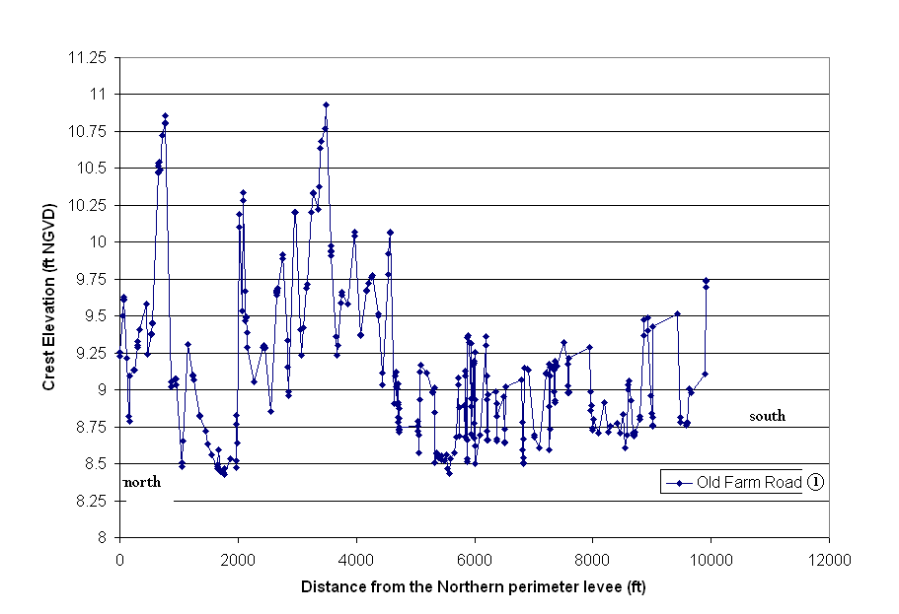
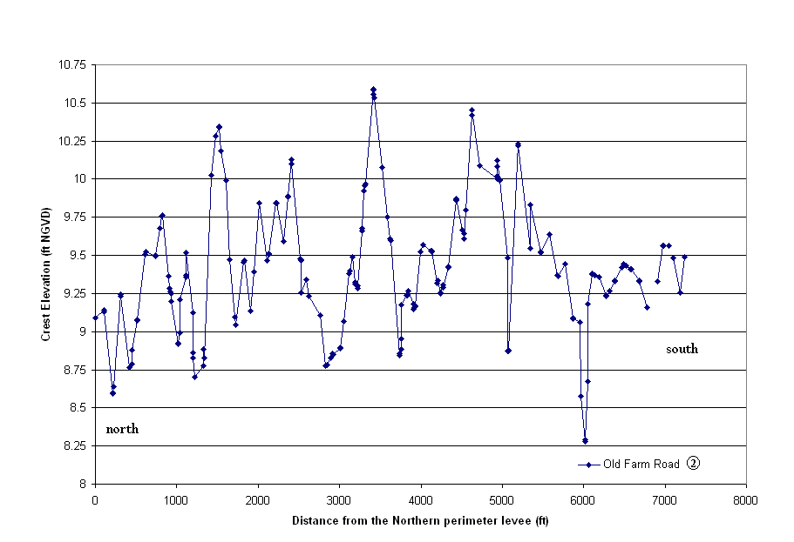
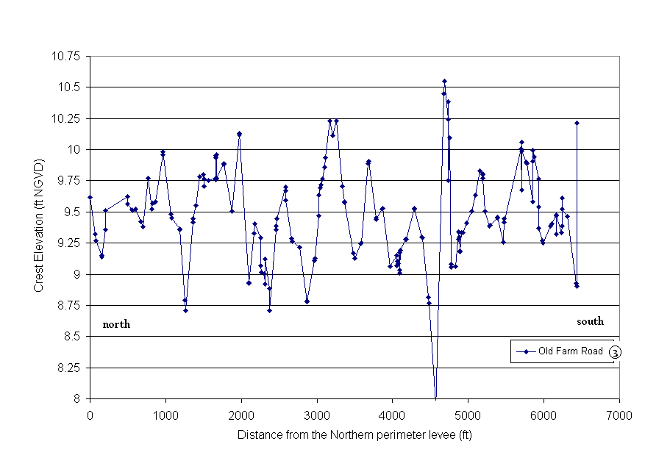

Figure 5: Surveyed Crest Elevations of the Old Farm Roads

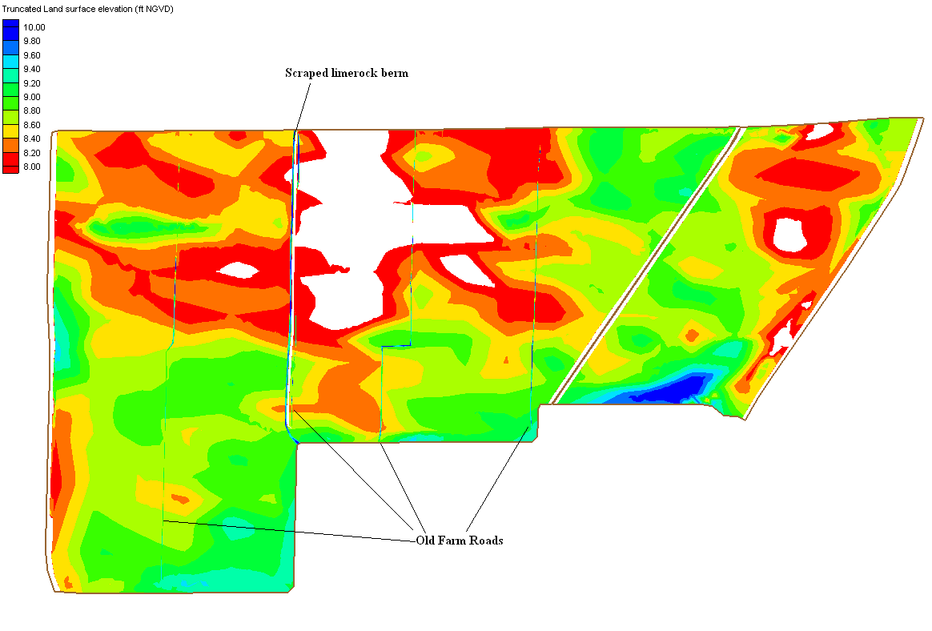
Figure 6: STA-1W Cell 5 Topographic data (elevations lower than 8.0 ft NGVD are not shown)

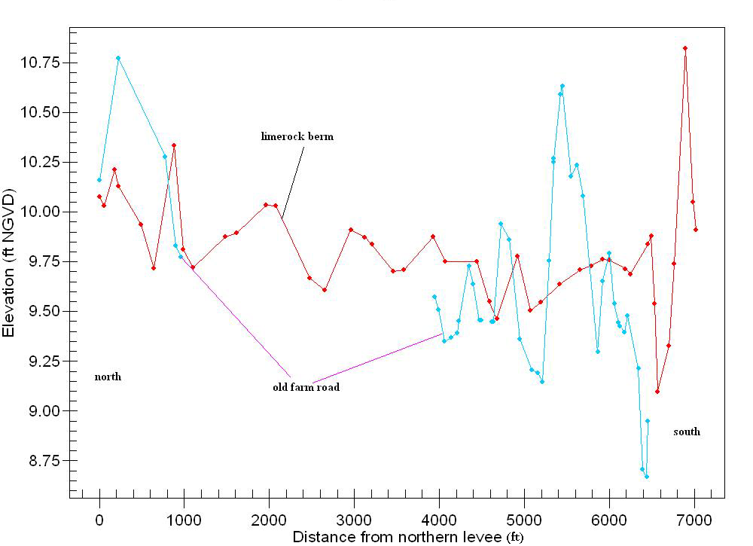

Figure 7: Crest Elevations of the Old Farm Road Segments next to the Limerock Berm

According to the Cell 5 proposed enhancements plan, small emergent vegetation strips are to be constructed on top of the old farm roads. The least cost alternative is to plant vegetation directly on top of the old farm roads without filling or grading. The most expensive one is to fill and grade the old farm roads to build earthen berms with a crest elevation of 9.75 ft NGVD (SFWMD, 2006). In addition, topographic enhancement in Cell 5A is proposed to include scraping some of the high areas and using the material to fill in nearby low areas to promote grow of emergent cattail in these areas.

Model parameters:

The bed shear stresses are applied to every element based on type of soil and vegetation. The Manning’s roughness coefficient (n value) is used in FESWMS. Since the enhancements are currently underway in Cell 5, it is not possible at the present time to adjust the Manning’s n values with model calibration.

Cell 5 is characterized by three different material type zones: emergent cattail, SAV and canals. A group of Manning’s n values were applied for the current modeling effort based on previous STAs modeling studies and best professional judgment. The following Manning’s n values were used in current model simulations (Table 1).

Table 1: Manning’s n Values used for STA-1W Cell 5

Depth (ft) | Emergent Cattail | SAV | Canals
≥3.0 | 0.5 | 0.3 | 0.038
1.5 | Varies linearly | Varies linearly | 0.038
1.0 | 1.2 | Varies linearly | 0.038
≤0.5 | 1.2 | 0.8 | 0.038

5. Hydraulic Analyses with the Updated Cell 5 Model

Several possible enhancement scenarios were selected for model simulations and hydraulic analyses based on information in the draft Cell 5 enhancements plan (SFWMD, 2006). The final as-built enhancement configuration is not yet available.

(1) Base cases

The model runs for base cases are defined as follows:

- The old farm roads are free of vegetation and have the same Manning’s n values as the canals;
- Structure Inflow: Design Peak Flow (1,470 cfs); Average Flow (600 cfs), or Low Flow (300 cfs);
- Downstream boundary conditions: specified stages (G306A-J headwater levels) at 10.0 ft NGVD (300 and 600 cfs) or 11.0 ft NGVD (1,470 cfs);
- SAV vegetation in Cell 5B and emergent cattail in Cell 5A;
- The 22 interior culverts G-305 A-V are fully opened.

In comparison to previous STA-1W Cell 5 modeling efforts (Sutron Corp., 2005), model setup for the current base cases differs in some of the local topographic features and vegetation coverages. The old farm roads were not incorporated in previous modeling efforts because the existence of these local topographic features was not known and the survey data were not available at that time. Cell 5A is emergent cattail dominant in the current model runs; however, it was mixed SAV and cattail in the previous Cell 5 modeling because emergent cattail was present only in the southern corner of Cell 5. The specified G-306A-J headwater levels (10.0 or 11.0 ft NGVD) are lower than in previous modeling, reflecting the fact that the limerock berm has been degraded from 11.5 ft NGVD and a lower average depth is preferred for future Cell 5 normal operation.

The computed water surface elevation, water depth, and velocity magnitude distribution for the three flow conditions are presented in the following plots.

Design Peak Flow (1,470 cfs): Figures 8-10.

This flow condition is the design maximum flow under Cell 5 normal operation. In reality, it is of short duration.

Water levels range from 11.0 ft NGVD to 12.02 ft NGVD. Computed water depth ranges from 0.47 ft to 4.2 ft in the marsh area. Velocity magnitude exceeds 0.1 ft/s in some local areas (local canals, old farm roads). The median velocity in the marsh area is approximately 0.07 ft/s. Local deep water depth areas are the major concern under this flow condition.

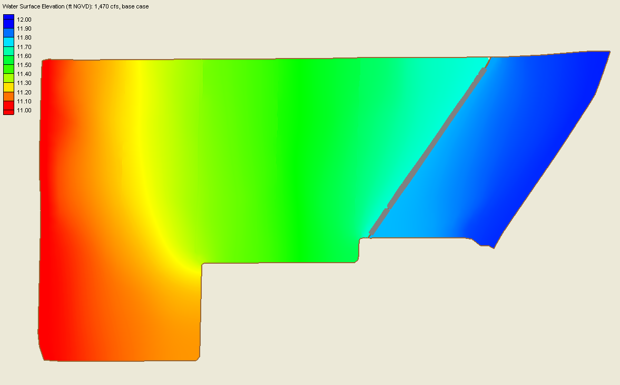
Figure 8: Water Surface Distribution (1470 cfs, base case)

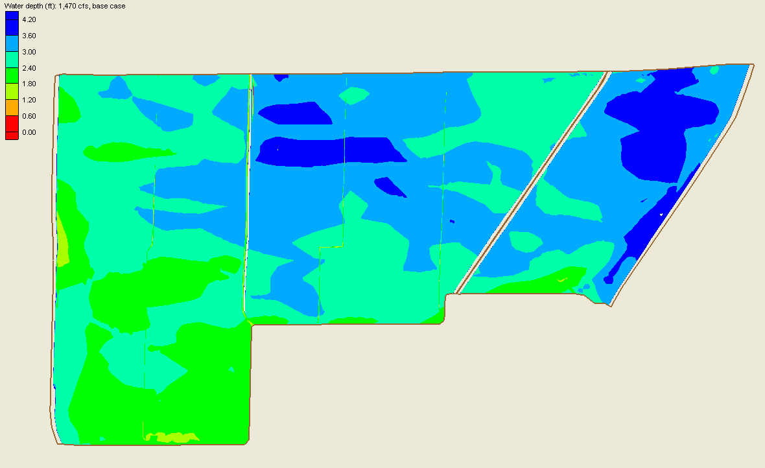
Figure 9: Water Depth Distribution (1470 cfs, base case)

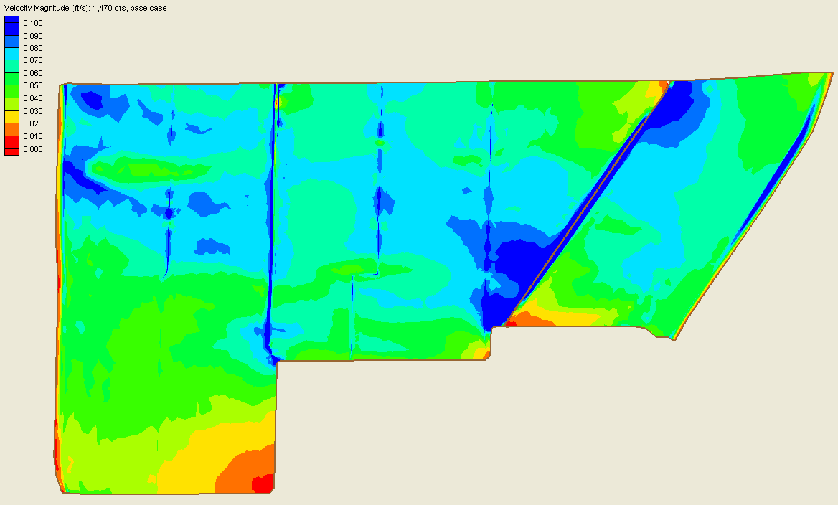
Figure 10: Velocity Magnitude Distribution (1,470 cfs, base case)

Average Flow (600 cfs): Figures 11-13.

This flow condition is considered as the Average Flow during Cell 5 normal operation.

Water levels range from 10.0 ft NGVD to 11.1 ft NGVD. Computed water depth ranges from 0.1 ft to 3.5 ft in the marsh area. Velocity magnitude is close to 0.1 ft/s in some local areas (local canals, old farm roads). The median velocity in the marsh area is approximately 0.05 ft/s. Water depth still exceeds 3.0 ft in the northern part of Cell 5A, and topographic enhancement would be necessary to reduce this condition.

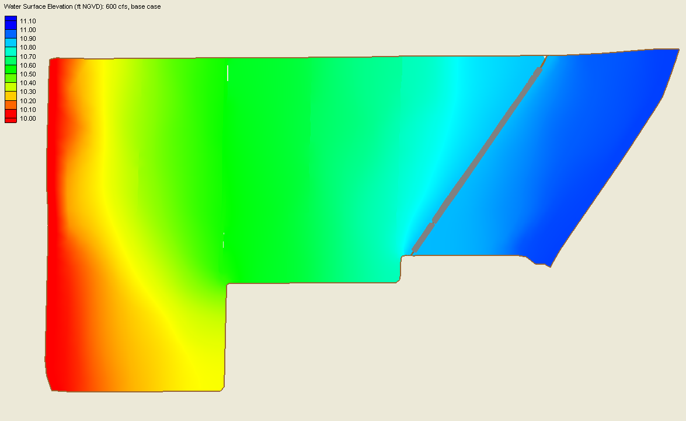
Figure 11: Water Surface Distribution (600 cfs, base case)

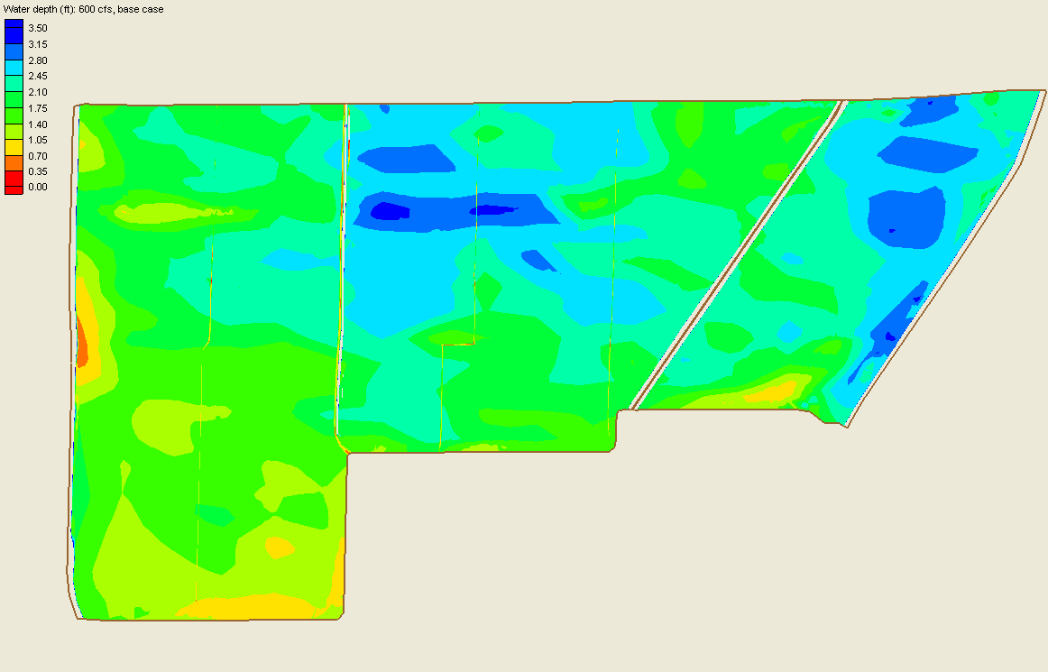
Figure 12: Water Depth Distribution (600 cfs, base case)

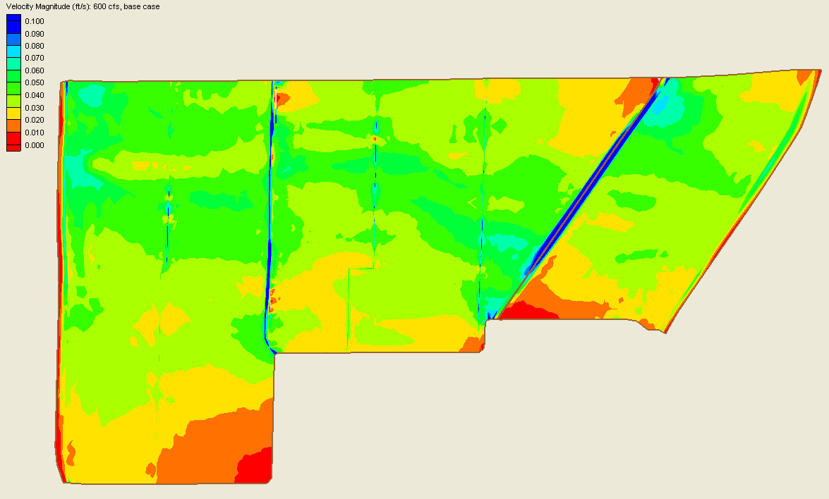
Figure 13: Velocity Magnitude Distribution (600 cfs, base case)

Low Flow (300 cfs): Figures 14-16.

This flow condition is considered as the Low Flow condition during Cell 5 normal operation.

Water levels range from 10.0 ft NGVD to 10.6 ft NGVD. Computed water depth ranges from 0.0 ft to 3.0 ft in the marsh area. The median velocity in the marsh area is approximately 0.03 ft/s.

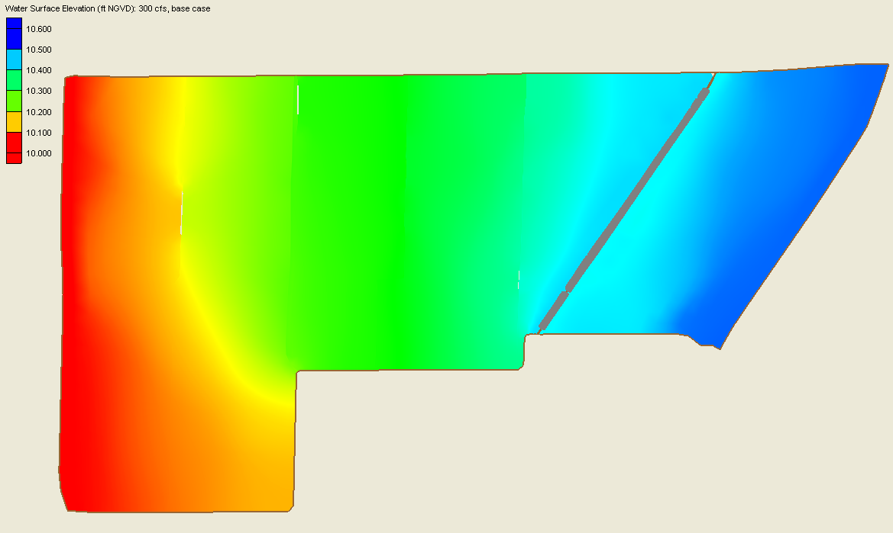
Figure 14: Water Surface Distribution (300 cfs, base case)

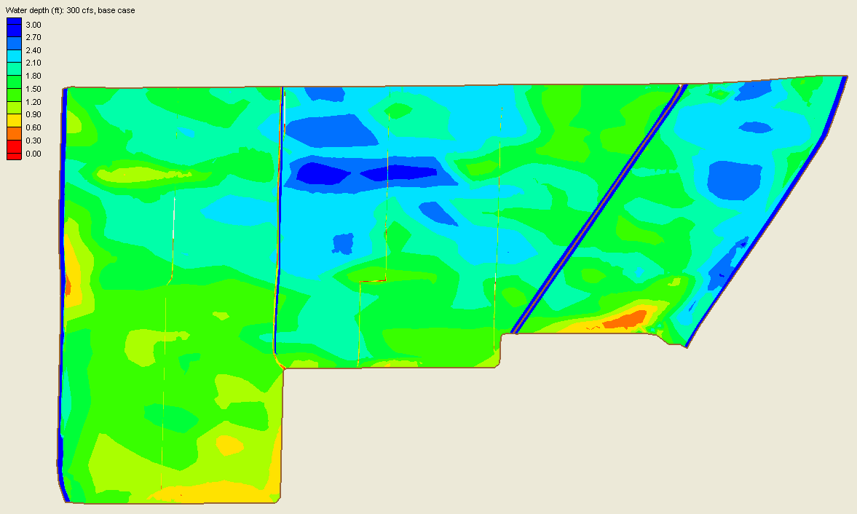
Figure 15: Water Depth Distribution (300 cfs, base case)

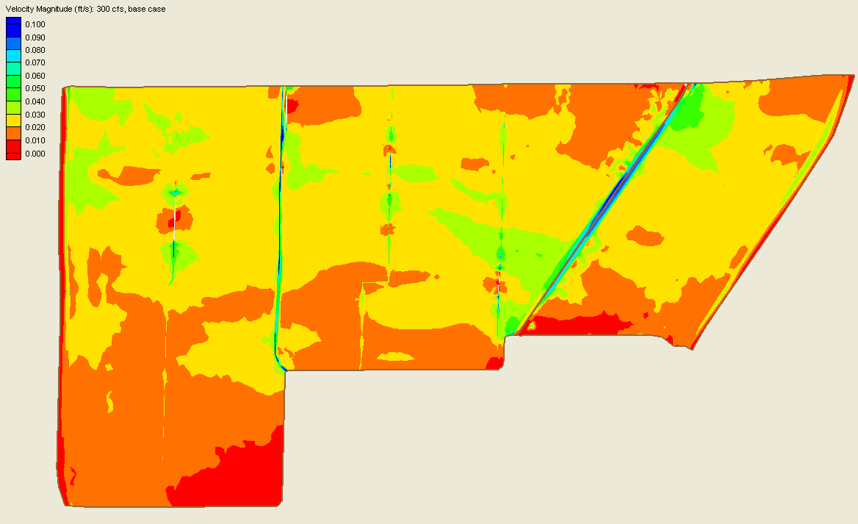
Figure 16: Velocity Magnitude Distribution (300 cfs, base case)

(2) Enhanced Alternative 1: Emergent vegetation strips will be planted on top of the old farm roads. No filling or grading of the old farm roads will be made.

The roughness coefficient at the old farm roads (emergent cattail vs. bare soil) is the cause of the difference from the base cases.

The differences between the enhanced condition and the base case simulations are summarized as follows.

Under the Design Peak Flow (1,470 cfs) condition, the increase in water depth due to the emergent vegetation strips is less than 0.1 ft (Fig. 17). The computed water surface profiles (base case and enhanced Alternative 1) along a longitudinal transect (A-A’, Figure 18) are compared in Figure 19. The reduced water depth at the locations of the emergent vegetation strips and the planting of emergent vegetation are the major source of the differences. The changes in velocity magnitudes are very small (Figure 20).

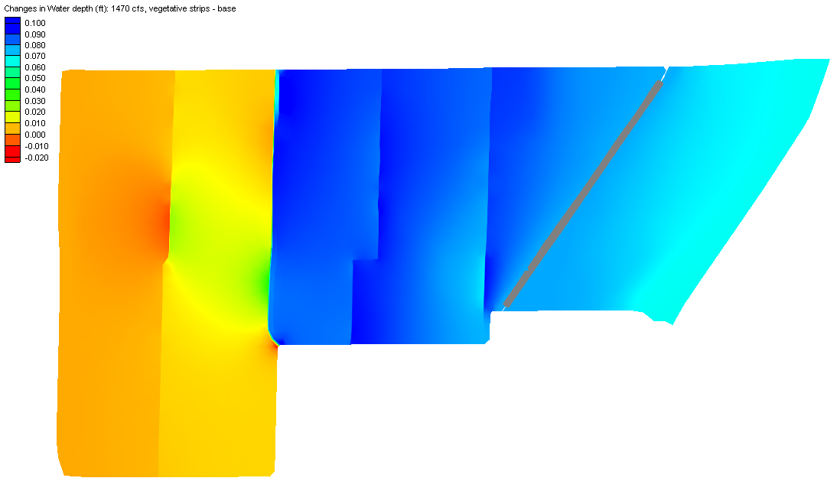

Figure 17: Changes in Water Depth Distribution (1,470 cfs, vegetation strips, no fill – base case)

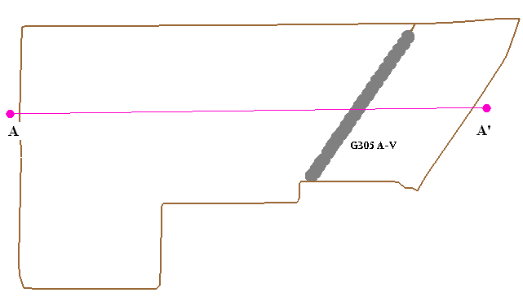
Figure 18: Location of Transect A-A’

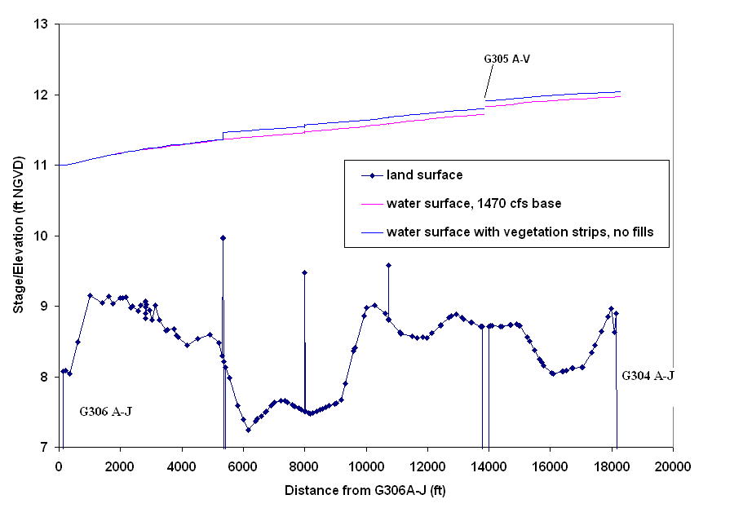
Figure 19: Transect (A-A’) Water Surface Profiles (1,470 cfs, enhanced and base case)

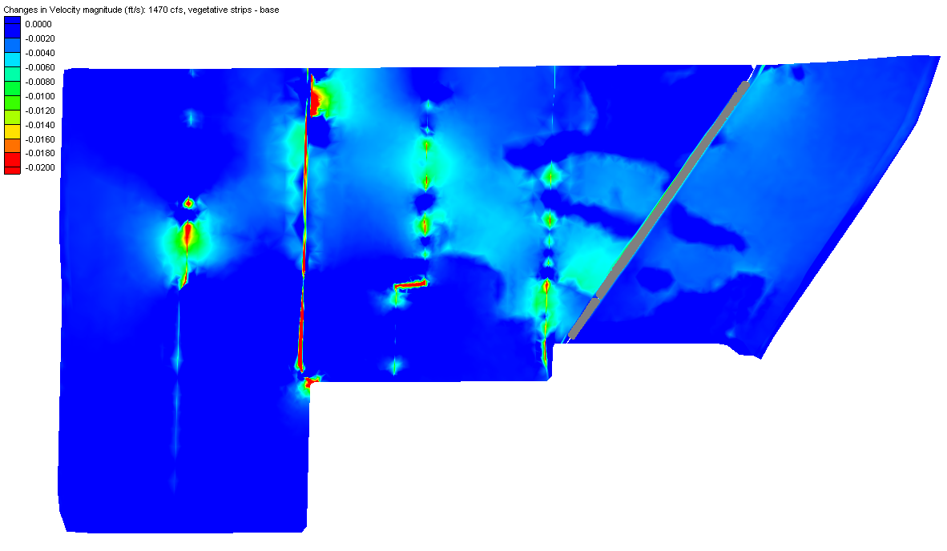

Figure 20: Changes in Velocity Magnitude Distribution (1,470 cfs, vegetation strips and no fill – base case)

Under the Average Flow (600 cfs) condition, the predicted increase in water depth due to the emergent vegetation strips is less than 0.16 ft (Figure 21). The computed water surface profiles (base case and enhanced Alternative 1) along a longitudinal transect (A-A’, Figure 18) are compared in Figure 22. The predicted changes in velocity magnitudes are also very small (Figure 23).

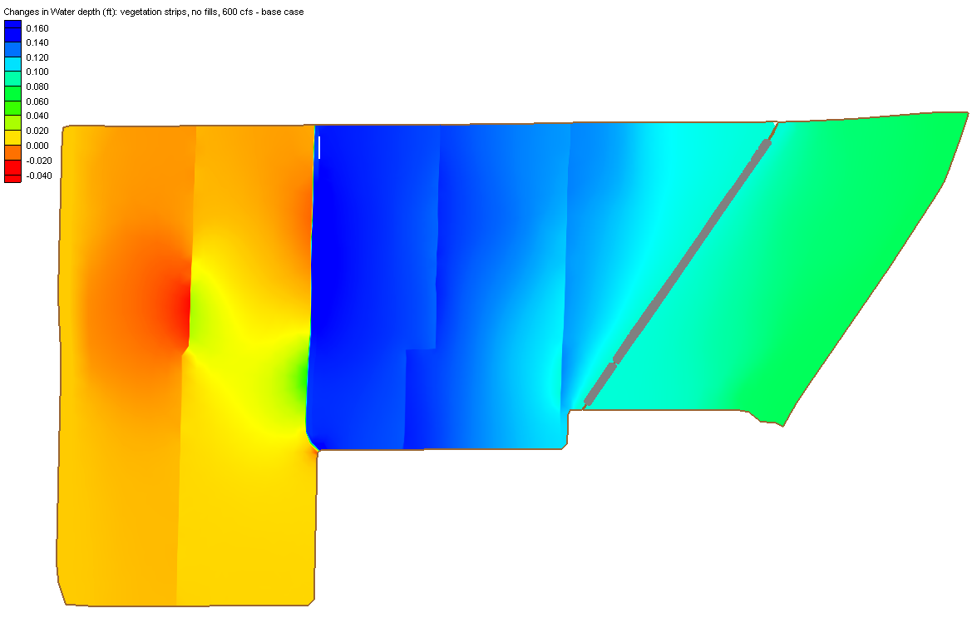
Figure 21: Changes in Water Depth Distribution (600 cfs, vegetation strips, no fill – base case)

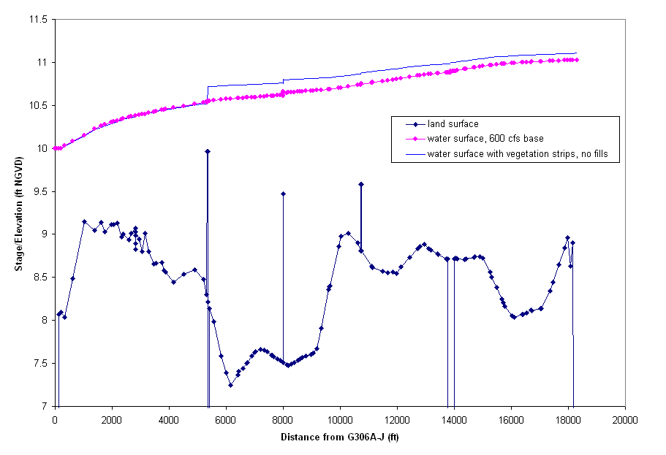
Figure 22: Transect Water Surface Profiles (A-A’) (600 cfs, enhanced and base case)

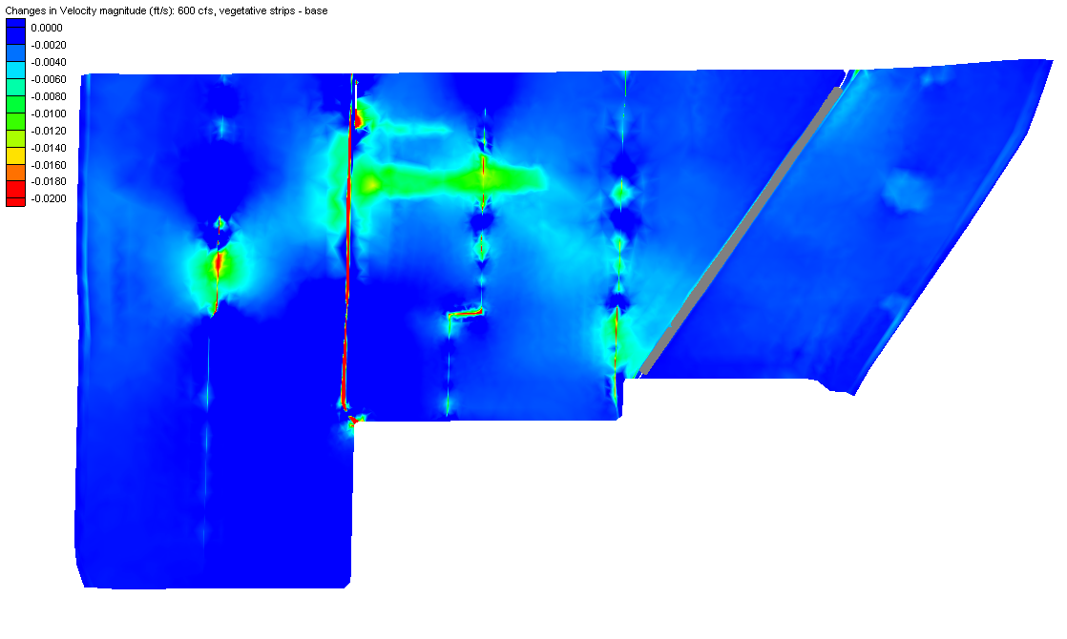

Figure 23: Changes in Velocity Magnitude Distribution (600 cfs, vegetation strips, no fill – base case)

Under the Low Flow (300 cfs) condition, the predicted increase in water depth due to the emergent vegetation strips is less than 0.16 ft (Fig. 24). The shallow depth at the location of emergent vegetation strips is the major source of the differences. The predicted changes in velocity magnitudes are very small (Figure 25).

The predicted velocity magnitude distribution is very similar before and after the emergent vegetation strips are added to the model (Figure 26) under three different flow conditions. There are very small predicted changes in velocity magnitude (less than 0.03 ft/s) in the marsh area. The predicted decrease in velocity magnitude is most significant at the location of the proposed vegetation strips (Figure 27) where water depth is shallower (Figure 28).

In summary, the addition of emergent vegetation strips in Cell 5B is predicted to have insignificant impact on Cell 5 hydraulics. Predicted changes in water depth ranges from -0.05 ft to 0.2 ft. and predicted changes in velocity magnitude in the marsh area are negligible.

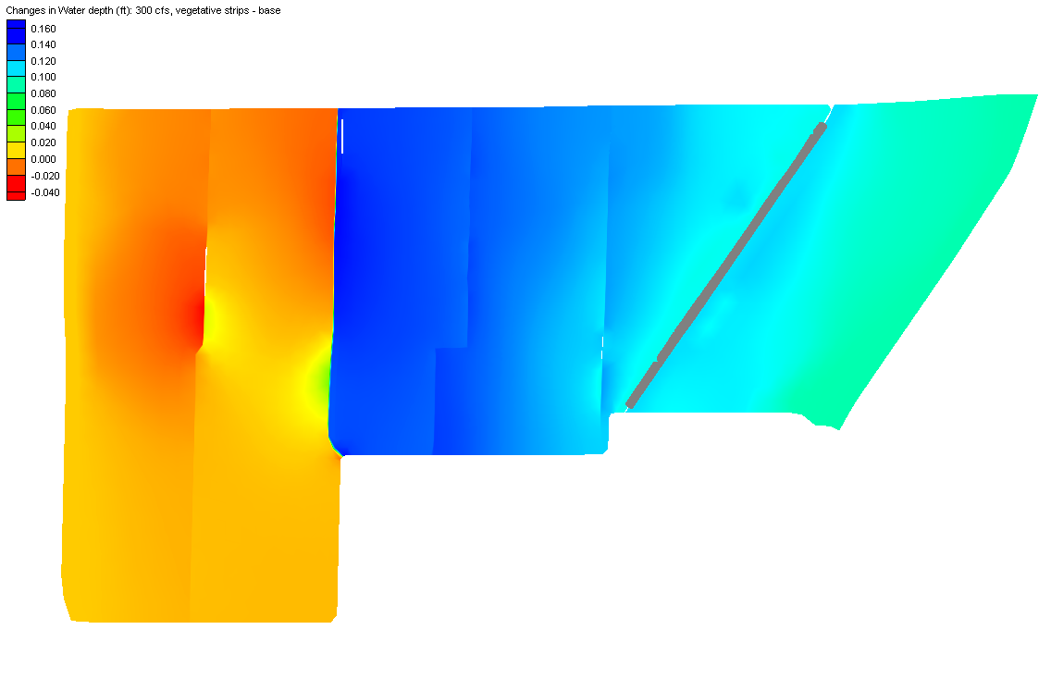
Figure 24: Changes in Water Depth Distribution (300 cfs, vegetation strips, no fill – base case)

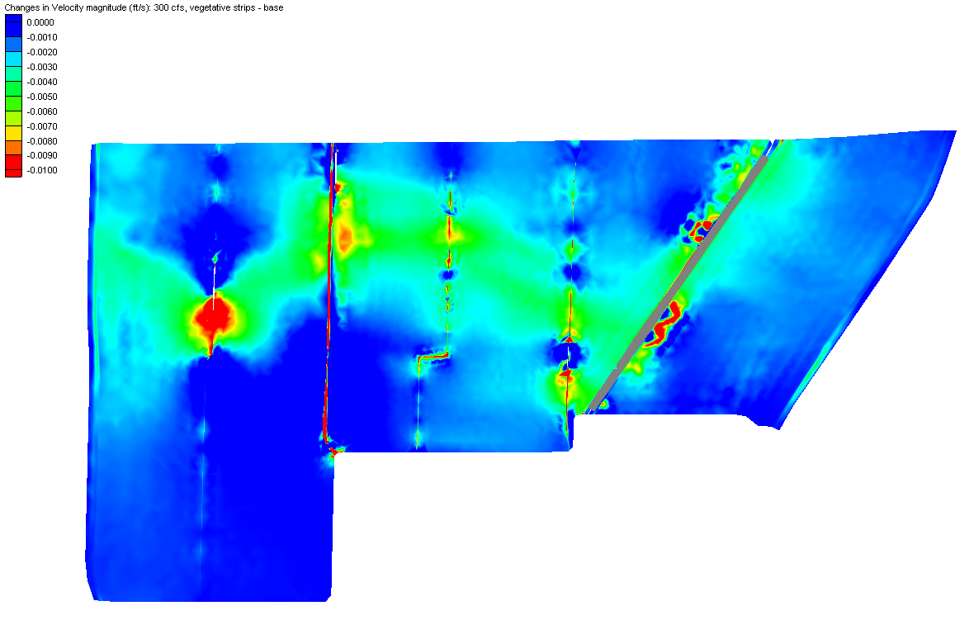
Figure 25: Changes in Velocity Magnitude Distribution (300 cfs, vegetation strips, no fill – base case)

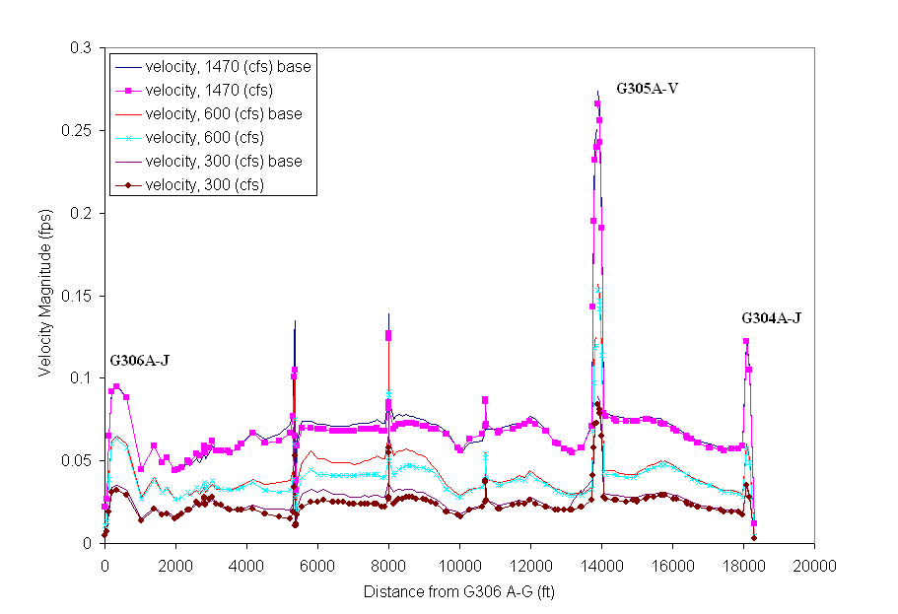
Figure 26: Velocity Magnitude Profiles along Transect A-A’ (vegetation strips without fill vs. base case)

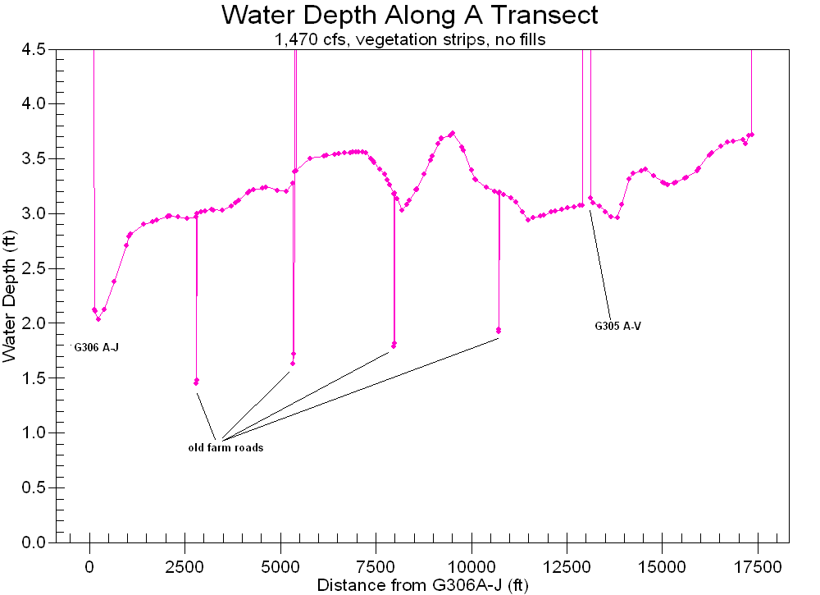

Figure 27: Water Depth Profile along Transect A-A’ (1,470 cfs, vegetation strips without fill)

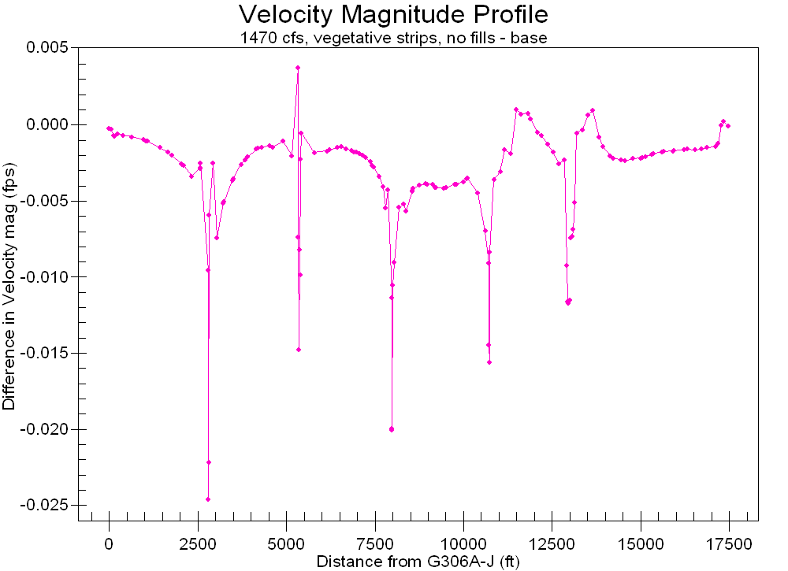
Figure 28: Changes in Velocity Magnitude along a Transect (A-A’) (1,470 cfs)

(3) Enhanced Alternative 2: For this alternative, the topography at the old farm roads was raised in the model to simulate filling material on top of the old farm roads. These raised berms were modeled to have a crest elevation of 9.75 ft NGVD (SFWMD, 2006). Emergent vegetation strips were also assumed to be planted on top of the berms.

From our discussion with District staff, this is the more expensive option and is less favorable than Alternative 1 (no fill). Therefore, only the Average Flow condition (600 cfs) was simulated for this option.

Flow obstruction or restriction was predicted in the simulation due to the shallow flow depth at the vegetation strips and greater resistance to flow incurred by the assumed emergent vegetation.

Simulation results show that the computed water depth values increased only slightly (Figure 29) compared to Alternative 1, the maximum difference changes from 0.16 ft to 0.22 ft (Figure 21). When the crest elevations of the old farm roads are raised in the model but there is no assumed planting of emergent vegetation on top of the raised farm roads, there are insignificant changes in the Cell 5 hydraulics compared to the base case. This demonstrates that in the model, the planting of emergent vegetation is more critical in restraining water flow compared to the raised topography. In the Enhanced Alternative 2, the prevailing water surface elevations range from 10.3 ft NGVD to 11.1 ft NGVD under the average flow condition (600 cfs); the old farm roads are well submerged under water, even after the crest elevations are raised to 9.75 ft NGVD.
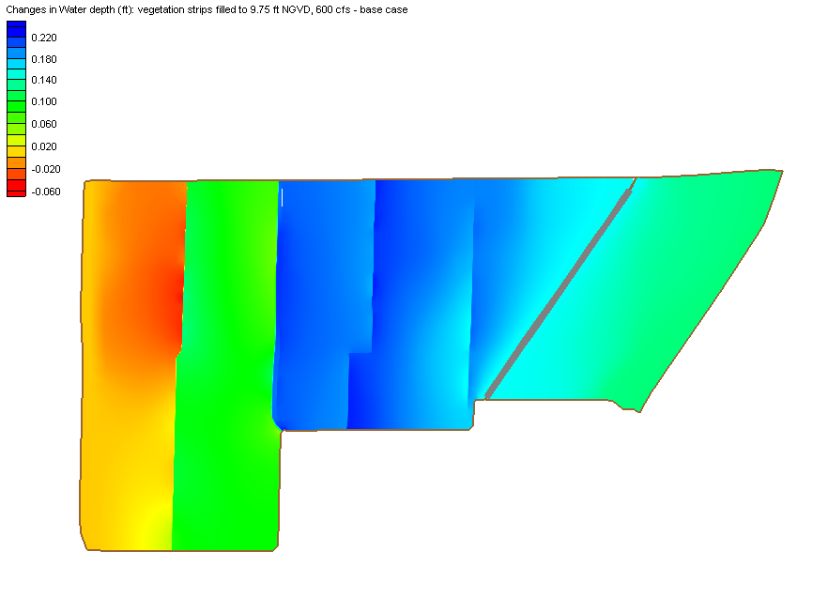
Figure 29: Changes in Computed Water Depth (600 cfs, vegetation strips, filled to 9.75 ft NGVD vs. base case)

6. Sensitivity analysis

The conclusions from the simulation results discussed above are based on a chosen model parameter set (mainly the Manning’s roughness coefficient values). Since the parameter values are not based on model calibration and history matching with observed data, it is necessary to know how the conclusions will be different if the selected parameters are biased from the true parameter values. Since we are more interested in the relative difference between two scenarios (base and enhanced cases), model calibration is less important than in absolute model prediction (e.g., predict future flow conditions for the same cell configuration). Furthermore, since the governing equations (shallow water equations) are physics-based, the relative comparison of model run results is considered reliable.

6.1 Numerical Errors

All model runs are transient simulations with constant boundary conditions; the simulation ends when steady state is maintained with little change in the numerical solutions. This is necessary because 22 culverts are explicitly simulated. Mass errors are checked for all model runs.

The effect of time steps, relaxation parameter and mesh size on simulation results were investigated through trial and error model runs and the model output was stable for all model simulations.

6.2 Manning’s n Values

Uncertainty in Manning’s n values can be estimated by sensitivity runs. One such method is to increase Manning’s n values for emergent cattail from (1.2, 0.5) to (1.3, 0.8), while all other conditions are kept unchanged. The base Manning’s n value increases by 60% (from 0.5 to 0.8). The case of Average Flow condition (600 cfs) was used as an example for illustration. Both Enhanced and Base Cases were simulated by applying the increased Manning’s n values for cattail and the difference in water levels is compared in Fig. 30. It can be seen that the results are very close to Fig. 21. The maximum difference is 0.19 ft and therefore the results are relatively insensitive to large changes in the Manning’s n value for emergent cattail.

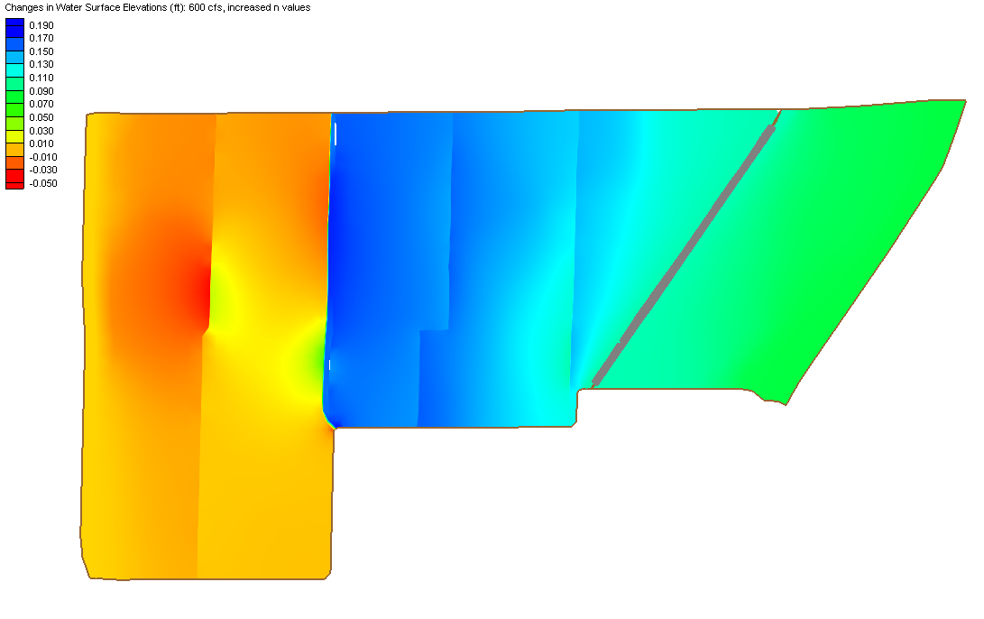
Figure 30: Changes in Computed Water Levels (600 cfs, after and before vegetation strips, increased n values)

6.3 Wind Effect

FESWMS has the ability to simulate wind effects on 2-D horizontal water flow. Since it was hypothesized that the vegetation strips might serve as wind breaks and possibly prevent the uprooting of SAV during high-wind events, a sensitivity model run was designed to investigate this hypothesis.

The sensitivity run was made for the design peak inflow of 1,470 cfs. Storm rainfall was not considered and only the Wind Effect was added. The high-wind event simulated was 90 miles per hour from the southeastern direction. For this simulation, a crest elevation of 9.75 ft NGVD was assumed for the vegetation strips (except for the scraped-down limerock berm).

In Figure 31, the changes in water surface elevations due to wind effect compared to no- wind condition are plotted for the 1,470 cfs Base Case. It can be seen that the model predicts significant impact due to the wind effect. At the southern boundary, water levels are much lower; there is even a dry-out area at the southwestern corner. Water is pushed toward the northwestern boundary, with an increase in water levels up to 0.3 ft. In Figure 32, the effect of vegetation strips on the computed water surface elevations under wind effect is compared. From the water surface distribution pattern, the vegetation strips lead to localized segmentation of water movement during a strong wind event. Pile-up of water at the northern boundary is obvious when there are vegetation strips.

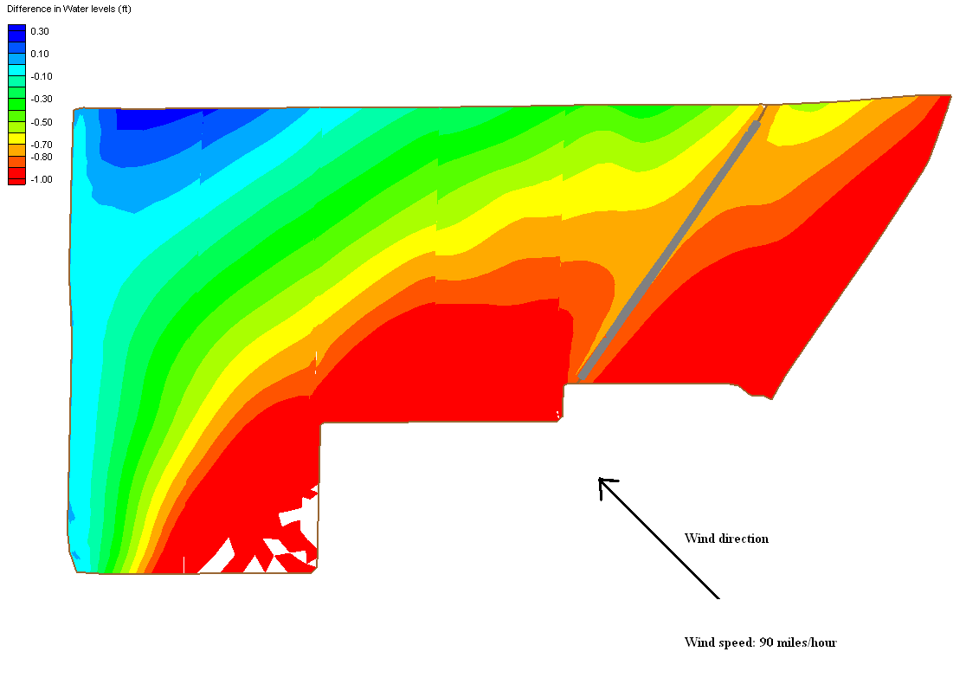
Figure 31: Impact of Wind Effect on Water Surface Elevations (1,470 cfs, no vegetation strips)

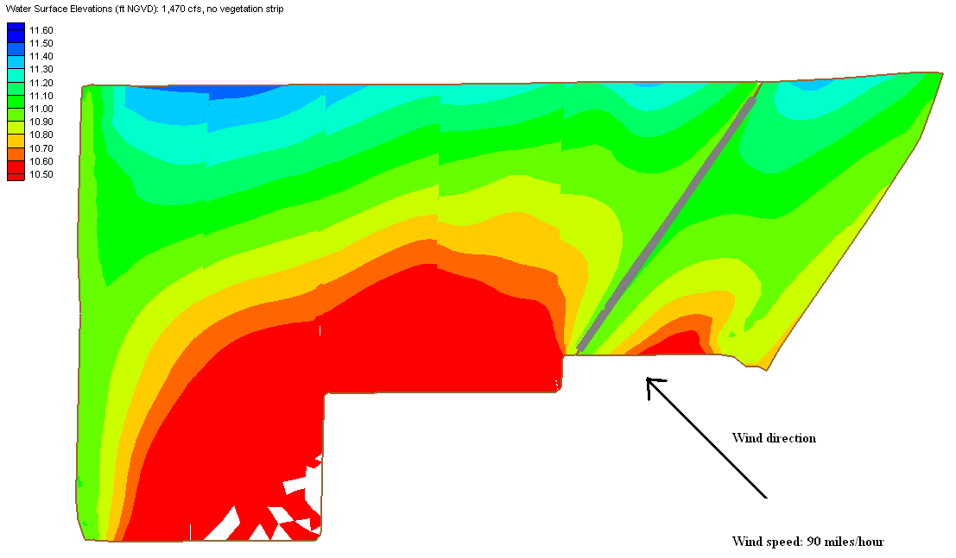 (a) Without Vegetation Strips
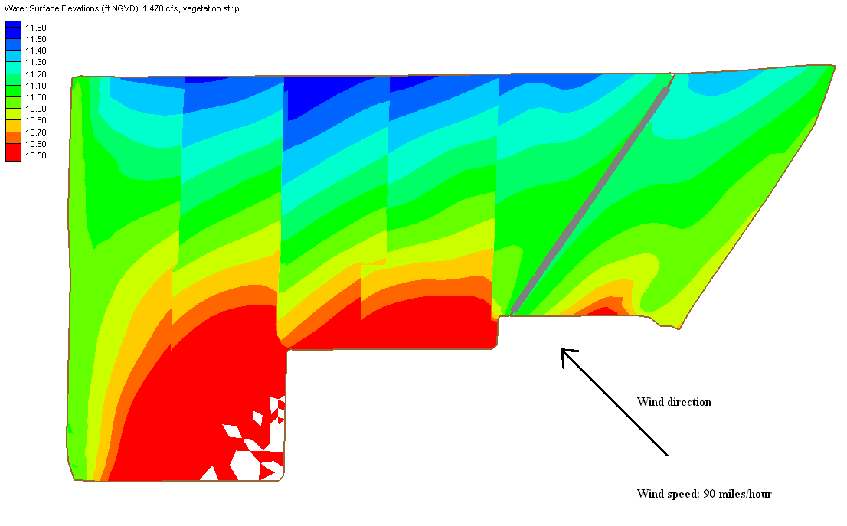
(b) With Vegetation Strips

Figure 32: Computed Water Surface Elevations With and Without Wind Effect (1,470 cfs, (a) no vegetation strips; (b) vegetation strips, filled to 9.75 cfs)

6.4 Topographic Enhancement in Cell 5A

The northern portion of Cell 5A has some extremely low areas. Due to the deep water depths in these areas, emergent cattail did not grow in well. One proposed enhancement is to fill these low areas to 9.0 ft NGVD, which would result in a reduction in the water depth of about 1.0 ft in the current deeper areas. When this is applied to the flow simulation of 600 cfs, with vegetation strips, the hydraulic effect was localized; water levels increased by 0.08 ft in northeastern part of Cell 5A (Figure 33).

The fill volume that would be needed to fill the Cell 5A low areas can be estimated from the stage-volume relationship. If the elevation of 9.0 ft NGVD is the desired bottom elevation, then the total volume of fill material needed would be about 380,000 cubic yards. Due to the time and cost associated with purchasing and installing this large quantity of fill, the District is currently not considering this substantial enhancement.

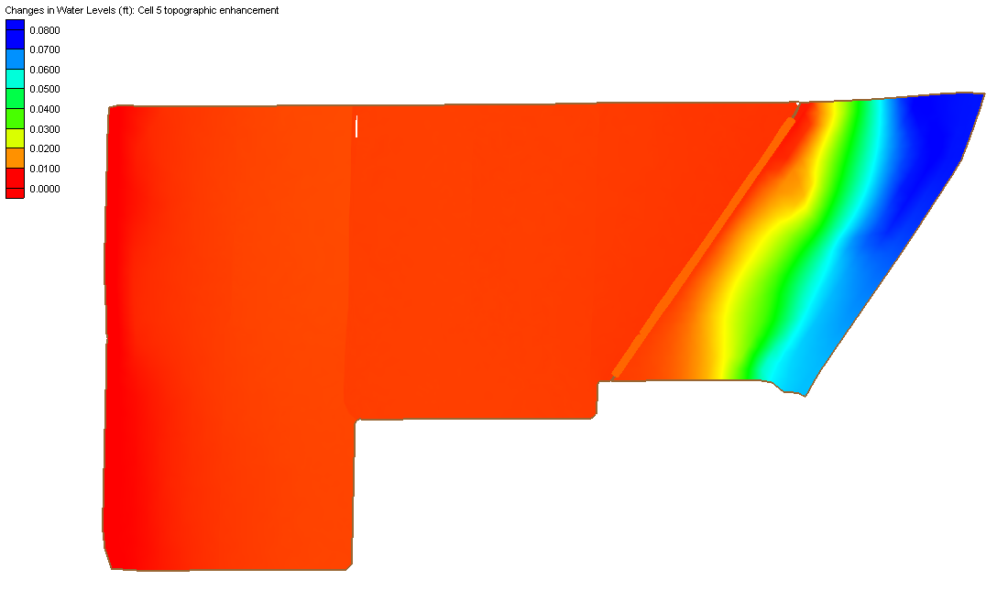
Figure 33: Changes in Water Surface Elevations (after and before Cell 5A topographic enhancement)

6.5 Cuts and Gaps in the Vegetation Strips

According to District staff, vegetation gaps or even cuts in the vegetation berms are not desirable due to the extra cost associated with making the cuts. From model simulations, the major factor in changing cell hydraulics was the addition of the emergent vegetation strips, not the raised crest elevation of the old farm roads.

A sensitivity run (600 cfs) was designed with gaps in the vegetation strips (bare soil in the place of emergent cattail at the gaps) under the raised crest elevation (9.75 ft NGVD) condition.

The simulation result shows that there is only small difference between the simulation with gaps and the simulation with no gaps (less than 0.1 ft for water depth) (Figure 34).

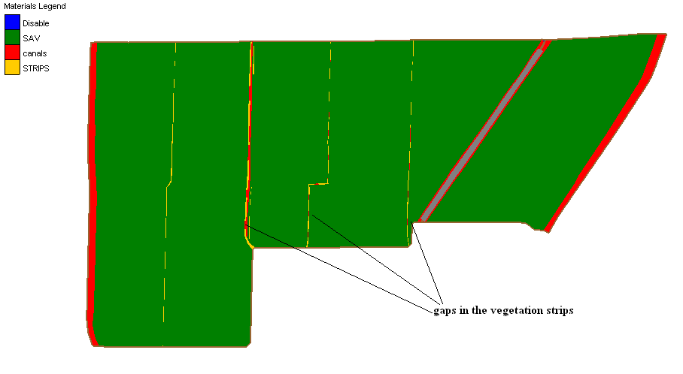
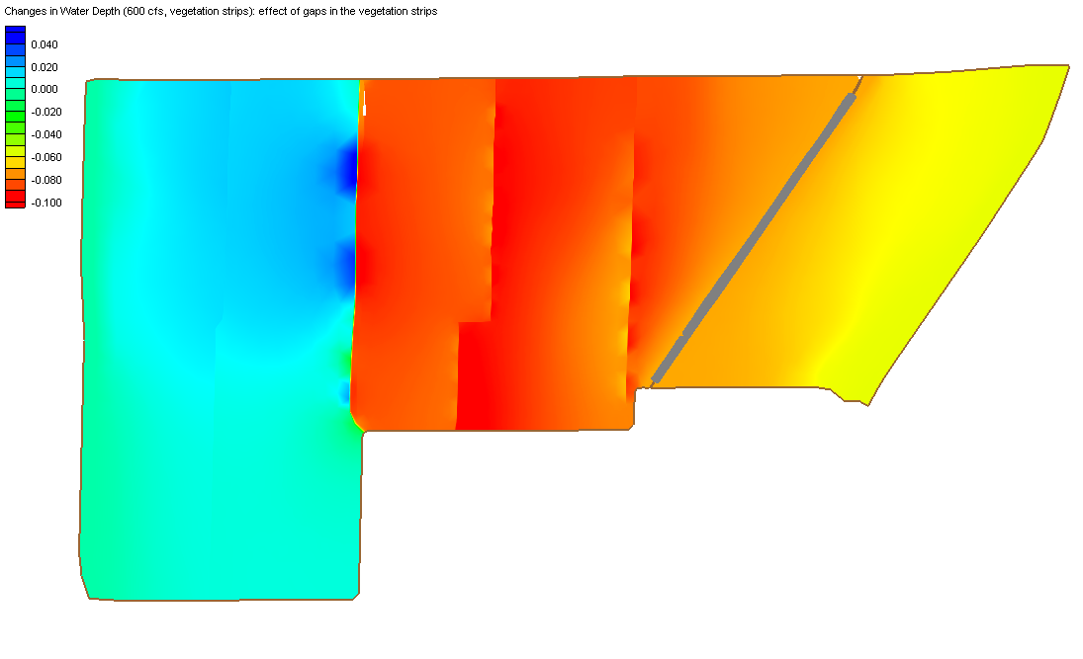
Figure 34: Difference in Computed Water Depth (600 cfs, vegetation strips with gaps and no gaps)

Since flow at the vegetation strips is not significantly obstructed according to the simulation results, gaps in the vegetation planting or even cuts in the earthen berms are not shown to have any impact either according to the simulation results.

7. Discussion

A detailed two-dimensional hydraulic analysis of proposed STA-1W Cell 5 enhancement alternatives showed that hydraulic performance will not change much after the enhancements are implemented (Table 2).

Table 2: Summary of Model Predictions

Scenarios | Configurations | Changes in water depth (ft)
Base Case:  No vegetation strips | 1,470 cfs  600 cfs  300 cfs | N/A
Enhanced Alternative 1:  Vegetation strips at old farm roads | 1,470 cfs  600 cfs  300 cfs | -0.02 to 0.1  -0.04 to 0.16  -0.04 to 0.16
Enhanced Alternative 2:  Vegetation strips and filling/grading the old farm roads (9.75 ft NGVD) | 600 cfs | -0.06 to 0.22

The computed changes in water depth due to the addition of emergent vegetation strips ranged from -0.06 ft to 0.22 ft based on Average Flow conditions, and absolute changes in velocity magnitudes in the marsh areas are smaller than 0.03 ft/s. Therefore, the hydraulic model can hardly discern the small differences among the different layouts and sizing of the vegetation gaps or cuts in the proposed vegetation strips. Sensitivity analyses also support the likely range of changes predicted by the current hydraulic modeling.

8. Conclusions

The 2-D hydraulic model of STA-1W Cell 5 was updated with new topographic survey data and used for hydraulic analysis of proposed Cell 5 enhancements.

The addition of emergent vegetation strips in Cell 5B will likely increase water depths by approximately 0.20 ft in Cell 5B, but there are insignificant changes in overall velocity distribution. Therefore, the impact of adding emergent vegetation strips on the Cell 5 hydraulics is insignificant, and flow obstruction resulting from the emergent vegetation strips will be negligible. The potential benefits of the emergent vegetation strips are in terms of Cell 5B segmentation and the addition of wind breaks to the cell.

References

DB Environment Inc. November 2004. Evaluation of Full Scale Stormwater Treatment Area Enhancements: STA1W-Cell 5 Tracer Project. Contract: ML040332, Prepared for South Florida Water Management District.

South Florida Water Management District (SFWMD). 2005. STA-1W Recovery Plan. West Palm Beach, Florida. September 21, 2005.

South Florida Water Management District (SFWMD). 2006. STA-1W, Cell 5 Sediment, Topographic and Vegetative Enhancements. West Palm Beach, Florida. January 31, 2006.

Sutron Corporation, prepared for South Florida Water Management District. 2005.
STA-1W Hydraulic Modeling Final Report, February 18, 2005
http://www.sfwmd.gov/org/erd/longtermplan/pdfs/STA-1w-final-report02182005.pdf

