December 12, 2008

Eric Buermann, Chair Carol Wehle, Executive Director
South Florida Water Management District South Florida Water Management District
3301 Gun Club Road 3301 Gun Club Road
West Palm Beach, Florida 33406 West Palm Beach, Florida 33406

Dear Mr. Buermann and Ms. Wehle:

On behalf of the Miami-Dade Legislative Delegation, I want to thank you both for your time and presentation on the pending U.S. Sugar land purchase by the state.

As you noted, there are an abundance of questions and issues yet to be resolved and the overwhelming sentiment from members of the delegation is that there is no justification to rush into this pending deal and that there is a strong desire for legislative review and input.

I make reference to the questions/concerns specifically raised by the members present as well as the looming questions posed in three of Florida's major newspapers (the St. Petersburg Times, Palm Beach Post, and Miami Herald) and their collective calls for delaying approval of the contract before you. Some of our questions and concerns include:

- Lack of a plan on how to pay for capital improvements once the land is acquired.
- The price that is being paid for the property, the appraisal method and the cost of future leases.
- The logic of diverting capital improvement dollars to the purchase of land therefore having a detrimental effect on jobs during tough economic times.
- Not enough information has been collected as to how the economic impact of the affected areas will place additional strains on fiscally constrained counties and what it will cost the state to provide assistance.
- Questions remain as to the reliability of the funding stream in these tough economic times when property values have been steadily decreasing. This in turn could force the District to raise their millage therefore raising taxes on Floridians.
- Lack of an “economic transition plan” offering new economic development opportunities and job creation to replace the 1,700 jobs that will eventually disappear and the cost to the state of this plan.

Although, we like the intentions behind the purchase and its general vision, we simply cannot be rash with taxpayer dollars. We have an obligation to the taxpayers of Miami-Dade County and to the rest of the state that this deal be well thought out and that we fully comprehend the impacts and consequences that may result from this decision.

Accordingly, as Chairman of this delegation, and on behalf of its members and the millions of constituents we collectively represent, we urge you and your fellow Board members to postpone
approval of the present purchase agreement of U.S. Sugar's land. Instead, continue your due diligence of this billion-dollar deal and allow time for proper legislative review and input during the upcoming 2009 Regular Session or during the committee weeks, or possible Special Session(s), that will precede it.

Thank you in advance. I trust that you will respect and honor this request by the delegation, whose county will pay the largest portion of this proposed purchase.

Sincerely,

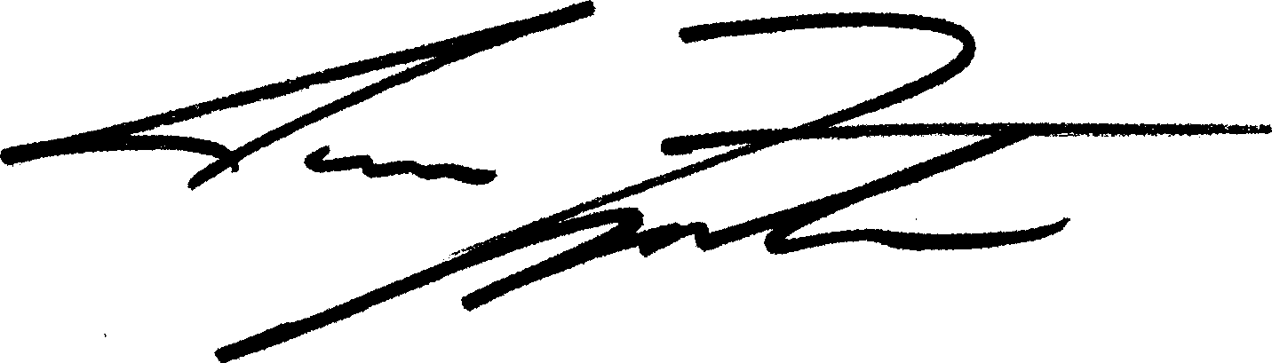

Juan C. Zapata Chairman, on behalf of all Miami-Dade Legislative Delegation Members

