**Submerged Aquatic Vegetation (SAV) Assessments**

**Quarterly Surveys**

The drought and managed lower lake levels during 2007 – 2009 have combined to produced favorable conditions for the recovery of the SAV community resulting in an increase in SAV biomass and areal coverage. Total acreage of SAV has increased from <3000 acres in 2006 to >46,000 acres in 2009. Additionally, lake conditions over the foreseeable future are expected to remain favorable for continued SAV growth as the new regulation schedule and CERP water storage projects should result in fewer extreme high and low conditions providing a more healthy range of water levels in the lake. Therefore the large spatial extent of SAV and the high biomass currently observed in the lake is expected to continue barring any extreme disturbances (natural or man-made).

The current method of sampling has become very labor-intensive and time-consuming due to the considerable volume of plant material that has to be processed for each sampling event. Beginning in January 2010, the monthly quantitative sampling will be replaced with quarterly qualitative sampling. The purpose of this is to provide data at a periodicity that is useful for real-time management of the lake in a manner that is time and cost effective. Plant samples are collected in the same manner as before (see Monthly Survey methods), but instead of weighing the plants to determine biomass, field staff visually determine whether the plant density is sparse, moderate, or dense. Comparisons with previous years weight data indicate that these visual evaluations generally correspond to sparse = less than 5 g dry weight / m2, moderate = 5 to 50 g dry weight / m2, and dense = greater than 50 g dry weight / m2.

Quarterly maps identifying distribution and abundance of SAV along the entire 16 transect sampling area are generated with these data.

**Results**

**2010**

**January 2010 (Fig. 1)**

The winter submerged aquatic vegetation (SAV) survey was completed at the beginning of January.  A total of 48 sites were sampled (26 in the north, 11 in the west, and 11 in the south) and plants were found at 30 of those sites (19 in the north, 7 in the west, and 4 in the south). Of the 30 sites with plants, 14 had dense vegetation, 10 had moderate vegetation and 7 had sparse vegetation.  Light penetration was good and average water level was 13.47 feet NGVD at the time of sampling. Moderate beds of *Vallisneria*, *Najas*, and *Potomageton* were observed along the western shore and moderate to dense beds of *Hydrilla* dominate the sites in Fisheating Bay.  The northern sites were dominated by moderate to dense beds of *Ceratophyllum,* *Najas* and *Hydrilla* interspersed with sparse beds of *Vallisneria*. *Chara* remains the dominant species in the south but most of the beds in the more turbid offshore sites have disappeared and the nearshore sites are sparsely vegetated. The two southern most transects are dominated by dense emergent vegetation (mostly cattail) which precludes efficient sampling of SAV.

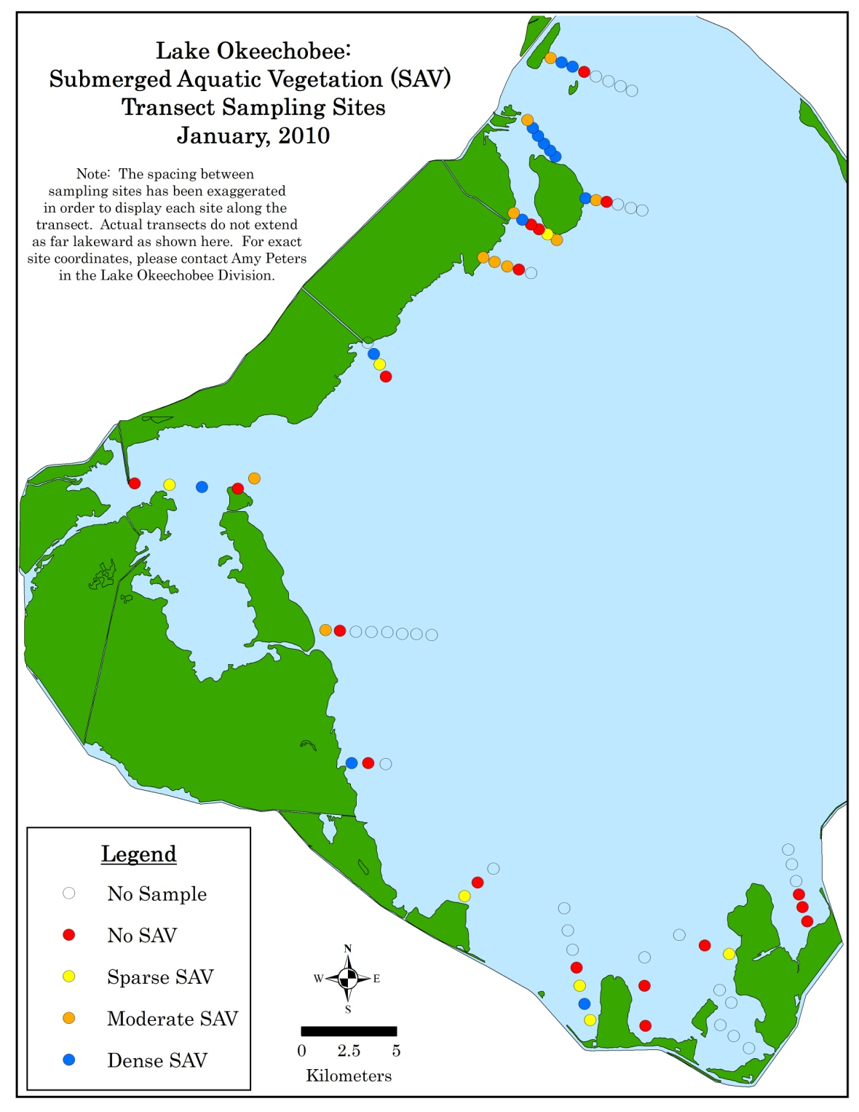

**Figure 1**. Distribution and abundance of submerged aquatic vegetation along 16 transects in January 2010.

**April 2010 (Fig. 2)**

The spring submerged-aquatic-vegetation (SAV) survey was completed at the beginning of April.  A total of 45 sites were sampled (26 in the north, 9 in the west, 10 in the south) and plants were found at 31 of those sites (21 in the north, 6 in the west, 4 in the south). Of the 31 sites with plants, 10 had dense vegetation, 11 had moderate vegetation and 10 had sparse vegetation.  Light penetration was good and average water level was 14.75 feet NGVD at the time of sampling. Moderate beds of Vallisneria and Potomageton continue to exist along the western shore and moderate to dense beds of *Hydrilla* still dominate the sites in Fisheating Bay.  The northern sites are dominated by the same species as those in the January survey.Most of the southern region *Chara* beds have not yet reappeared from their typical winter decline but the nearshore sites have scattered pockets of dense *Ceratophyllum*. April’s total of 31 vegetated sites compares favorably with the 41 and 30 vegetated sites encountered respectively in October 2009 and January 2010, in light of the known seasonality of SAV in Lake Okeechobee.

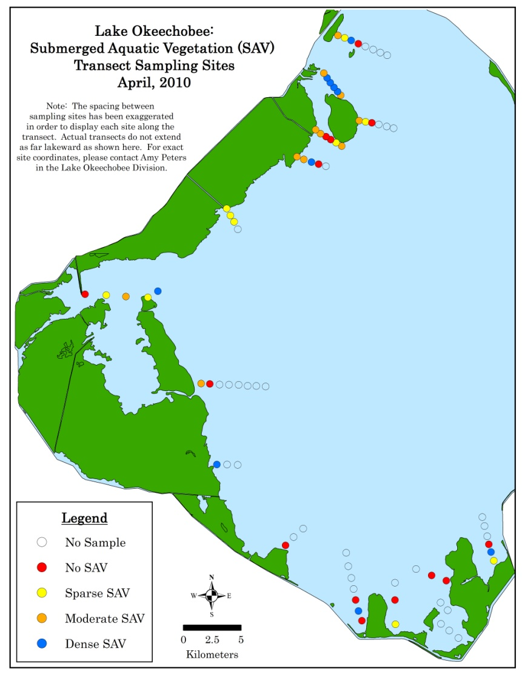

**Figure 2**. Distribution and abundance of submerged aquatic vegetation along 16 transects in April 2010.

**July 2010 (Fig. 3)**

The summer submerged-aquatic-vegetation (SAV) quarterly survey was completed at the beginning of July.  A total of 50 sites were sampled and plants were found at 39 of those sites (20 in the north, 7 in the west, 12 in the south). Of the 39 sites with plants, 12 had dense vegetation, 12 had moderate vegetation and 15 had sparse vegetation. Light penetration was good and average water level was 14.36 feet NGVD at the time of sampling. *Chara has* started to make a comeback in the south with sparse beds at seven sites and dense beds at two sites. Overall, plant coverage showed increases from the April 2010 survey (figure 2).

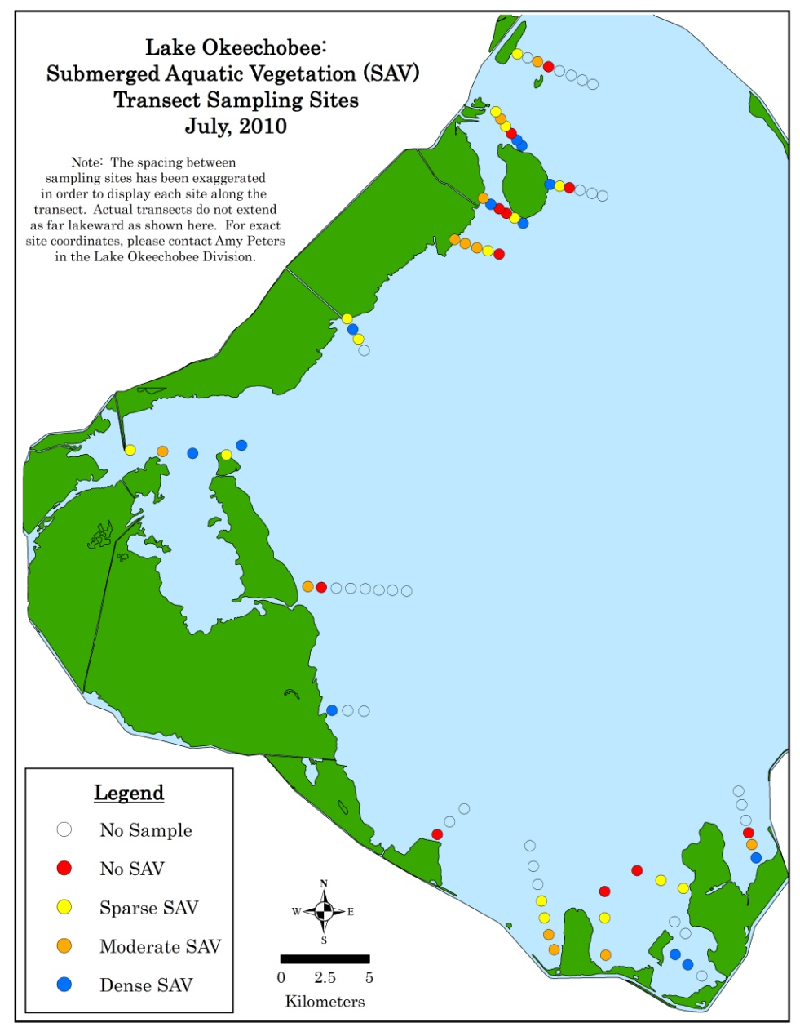

**Figure 3**. Distribution and abundance of submerged aquatic vegetation along 16 transects in July 2010.

**October 2010 (Fig. 4)**

The fall submerged-aquatic-vegetation (SAV) survey was completed on October 13.  A total of 51 sites were sampled and plants were found at 37 of those sites (21 in the north, 7 in the west, 9 in the south). Of the 37 sites with plants, 8 had dense vegetation, 11 had moderate vegetation and 18 had sparse vegetation. Hydrilla and Ceratophyllum were the most common species found especially in the north and west.  These results are similar to the summer SAV survey results (figure 3). Light penetration was good and average water level was 13.83 feet NGVD at the time of sampling. October’s total of 37 vegetated sites compares favorably with the 37 and 41 vegetated sites encountered respectively in July and October of last year.

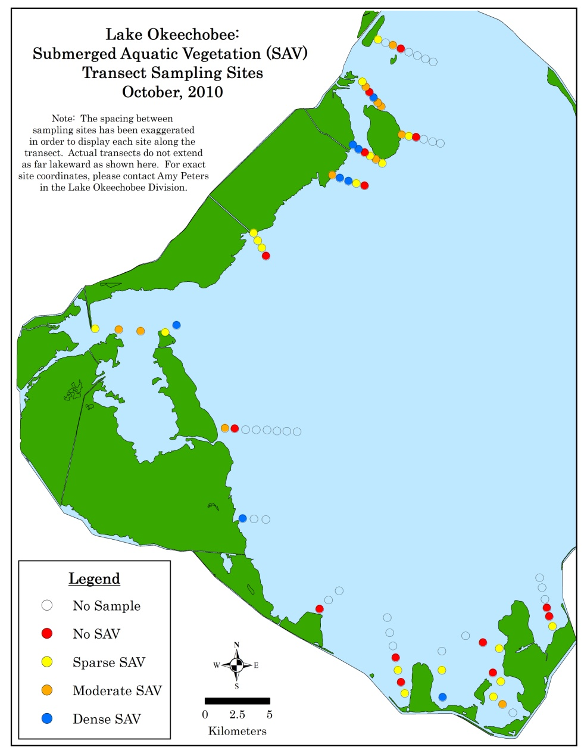

**Figure 4**. Distribution and abundance of submerged aquatic vegetation along 16 transects in October 2010.