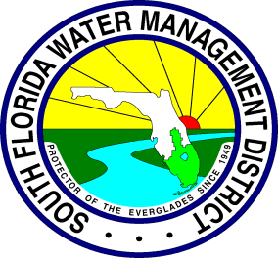

Fiscal Year 2012

Broward County Initiative CBIR

Stormwater Project Information

PROJECT SUMMARY FORM

- PROJECT INFORMATION:
Project Title:

Project Location: (map establishing relevancy to specific water body preferred)

Project Sponsor
Entity Name:
Address:
Contact Person/Title: Phone Number:
E-Mail Address:

Funding history
Total Estimated Project Cost
Total cost of project this year
Legislature funding request

PROJECT BACKGROUND

- PROJECT GOALS AND OBJECTIVES

- PROJECT DESCRIPTION

- MEASURABLE OUTCOME ANTICIPATED and PROJECT NEED

Please list the quantifiable targets of the project.

Water Quality improvement is vital to the project’s success and will be implemented by reducing pollutant loads (Table –A) by ___% into the_________ body of water within the _____Boundaries. This improvement of water quality is both anticipated and expected as a result of the proposed stormwater management project.

Table-A
Proposed Pollutant Load Reduction

BMPs Installed |  | TSS  kg/yr | TP  kg/yr | TN  kg/yr
Treatment Trains |  | TSS  kg/yr | TP  kg/yr | TN  kg/yr
Pollutant Loads | Pre-Project
Pollutant Loads | Post-Project
Pollutant Loads | Load Reduction
Pollutant Loads | % Reduction (*)

(*) 80% or higher preferable.
If there are none, please explain why.

Need for Project
a. What are the benefits of this project? (check all that apply)

_____Water Quality
_____Drainage
_____Flood Control
_____Resolve Violation
_____Resolve Recurring Problem
_____Habitat Restoration
Other:________________________________________________

b. Please Explain:

- PROJECT SCHEDULE
- What is the current status of the project (is it under construction, does it have permits, etc.)?

- Can this project (or project phase) be completed within the SFWMD’s fiscal year?

- Can the requested funds be expended within the SFWMD’s fiscal year?

- If the project is one phase of a multi-phased project, describe the work to be completed each fiscal year, through project completion (Add more years if needed):

FY 2010-2011

FY 2011-2012

FY 2012-2013

If the project cannot be completed within 1 year or the project is one phase of a multi-phased project, describe the work through project completion:

FY 2012/13

FY 2013/14

- CONTACTS

SFWMD | Jose L. Lopez, Stormwater Division, Broward Service Center
Local Sponsor | Contact Person/Title: Phone Number:  E-Mail Address

