Submerged Aquatic Vegetation (SAV) Assessments
Monthly Surveys
Since spring 1999, District scientists have been documenting the abundance and distribution of submerged aquatic vegetation (SAV) in the Lake by conducting monthly surveys of stations located along 16 fixed transects encompassing the Lake's south and west shoreline. This covers a region where SAV beds historically have occurred. The sampling includes measurements of plant biomass, water chemistry, clarity of the water, and underwater light penetration.
In order to obtain quantitative estimates of plant species biomass, sampling is done at sites located along 16 transects in areas of the lake that support submerged plants (Fig. 1). On a monthly basis triplicate samples are collected at sites along each transect, starting at the shoreline and progressing lake ward until a site is reached with no plants. Plants are sampled using a tool constructed of two standard garden rakes bolted together at midpoint to create a tonglike device. The degree of opening is constrained by placing a chain between the two handles, such that three replicate samplings with the device removes ~1 m² of bottom cover. The harvested material is sorted by species, stripped of epiphyton, and analyzed for dry mass. At the same time that plant sampling is done, measurements are made of total depth, Secchi depth, and sediment type. Data from the SFWMD water quality monitoring program, which includes stations in the vicinity of all SAV sampling sites, is used to identify other water quality conditions, including underwater irradiance and temperature profiles, color, chlorophyll a, total and soluble phosphorus, total and soluble nitrogen, and total and non-volatile suspended solids. The water chemistry data is important to understanding the light-attenuating properties of the water and explaining observed trends or patterns in submerged vegetation.
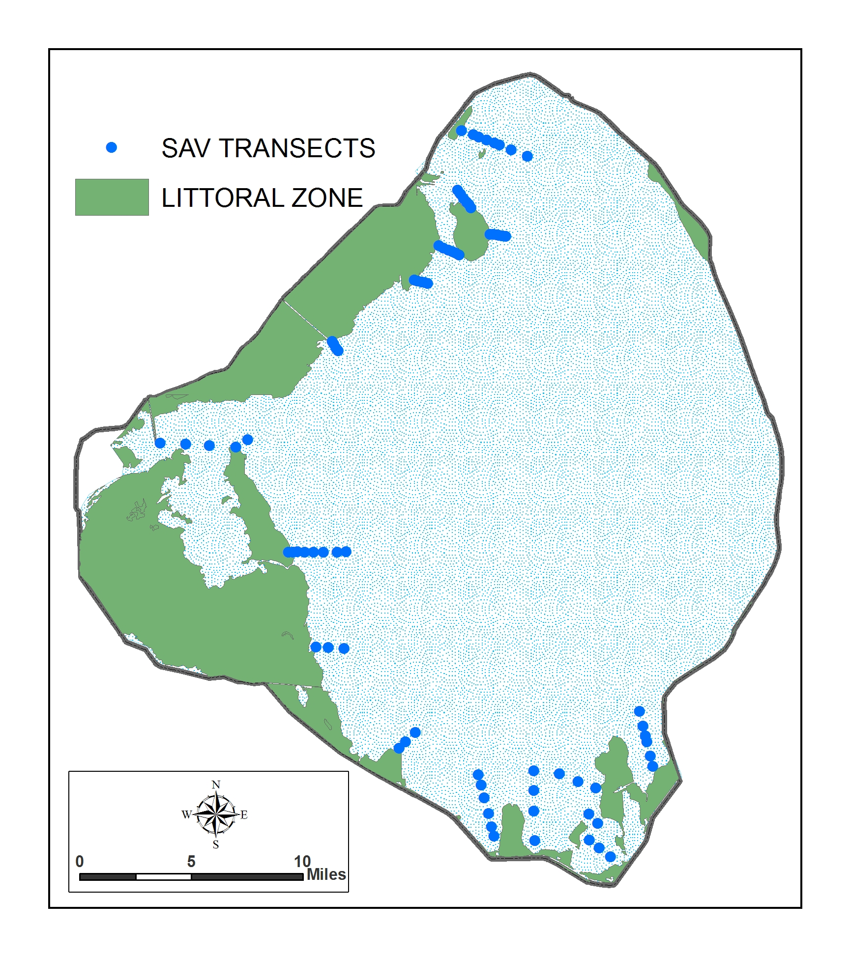

Figure 1. Locations of sites along transects for monthly submerged aquatic vegetation sampling (SAV).

Results:

Seven sites considered representative of the lake's shoreline area: three sites in South Bay, one site to the west of Ritta Island, one site in Fisheating Bay, one site to the west of King's Bar, and one site near Eagle Bay, at the lake's north end will be reported here. Monthly maps of plant distribution and abundance for all sites along the 16 transects may be obtained by contacting Amy Peters at apeters@sfwmd.gov.
2009
January 2009
Water levels continue to decrease and conditions are favorable for SAV growth and development. Two of the seven sampling sites were still too dense with cattail and eleocharis to sample efficiently (Halifax and Bay Bottom). Harney Pond, King’s Bar West and Eagle Bay had sparse Vallisnaria, and Hydrilla and the two northern sites also had sparse Ceratophyllum. Ritta West and Ritta East had no plants.
February 2009
Conditions were the same as in January except at the two northern sites (King’s Bar West and Eagle Bay) where plant densities increased to moderate levels.
March 2009
Moderate plant densities persist at the north sites (King’s Bar West and Eagle Bay) and densities increased to moderate levels in Harney Pond. Chara (the predominant species in the south end of the lake) is still absent from the southern sites and the most nearshore sites of Halifax and Bay Bottom still can’t be sampled efficiently because of dense emergent vegetation.
April 2009
Dense beds of Hydrilla and Ceratophyllum were present at Eagle Bay and Harney Pond while densities remained at moderate levels in King’s Bar West. Chara is still absent from the southern sites and the most nearshore sites of Halifax and Bay Bottom still can’t be sampled efficiently because of dense emergent vegetation.
May 2009
Sparse Chara is beginning to emerge at the southern sites of Ritta East and Ritta West but the two nearshore sites are still dominated by dense emergent vegetation (mostly cattail). Dense beds of Hydrilla and Ceratophyllum were present at Eagle Bay and Harney Pond while densities remained at moderate levels in King’s Bar West.
June 2009
Moderate to dense beds of Hydrilla and Ceratophyllum interspersed with moderate levels of Vallisneria and Najas persist at the northern and western sites (Eagle Bay, King’s Bar West and Harney Pond). Sparse Chara continues to emerge at the southern sites of Ritta East and Ritta West but the two nearshore sites are still dominated by dense emergent vegetation (mostly cattail).
July 2009
Water levels continue to gradually decline and light conditions are optimal for SAV growth. Moderate to dense plants beds are thriving in the north and west and Chara is increasing in the south.
August 2009
Quantitative sampling was not conducted this month due to extensive yearly mapping efforts. See results on the "Yearly Mapping" page of this web site.
September 2009
Quantitative sampling was not conducted this month.
October 2009
Moderate to dense plants beds continue to thrive in the north and west (Eagle Bay, King’s Bar West and Harney Pond) and Chara is increasing to moderate levels at the southern sites of Ritta East and Ritta West. The two nearshore sites of Halifax and Bay Bottom still can’t be sampled efficiently because of dense emergent vegetation (mostly cattail).
November 2009
Sampling was not conducted this month.
December 2009
Sampling was not conducted this month.

2008
January 2008
Lake levels remained steady but low and two of our seven sites were dry (Halifax and Bay Bottom). Two sites had sparse Chara (Ritta East and Ritta West), two sites had sparse Vallisneria (Fisheating Bay and King’s Bar West), and one site had no plants (Eagle Bay).
February 2008
Lake levels remained steady but low and two of our seven sites were dry (Halifax and Bay Bottom). Two sites had sparse Chara (Ritta East and Ritta West), two sites had sparse Vallisneria (Fisheating Bay and King’s Bar West), and one site had no plants (Eagle Bay).
March 2008
Lake levels remained steady but low and light levels at the bottom remained high. Two of our seven sites were dry (Halifax and Bay Bottom), two sites had sparse Chara (Ritta East and Ritta West), two sites had sparse Vallisneria (Fisheating Bay and King’s Bar West), and one site had no plants (Eagle Bay).
April 2008
Drought conditions and high light penetration continued. The plant community was the same as in March.
May 2008
Conditions were the same as in April.
June 2008
Drought conditions and high light penetration continued. Of the seven sites sampled this month, two remained dry (Halifax and Bay Bottom) and three had submerged vegetation. Ritta East had moderate Chara, Ritta West had sparse Chara, and Fisheating Bay had sparse Vallisneria. Two sites had no plants (King’s Bar West and Eagle Bay).
July 2008
Of the seven sites sampled this month, two were dry (Halifax and Bay Bottom) and four had submerged vegetation. Ritta East had moderate Chara and Ritta West, Fisheating Bay and King’s Bar West all had sparse Chara. Fisheating Bay and King’s Bar West also had sparse Vallisneria. Eagle Bay did not have any plants.
August 2008
Five of the seven sites sampled this month had submerged vegetation and two were dry (Halifax and Bay Bottom). Ritta East and Ritta West both had moderate Chara and Fisheating Bay, King’s Bar West and Eagle Bay had sparse Vallisneria. Fisheating Bay also had sparse Hydrilla and Eagle Bay also had sparse Chara. The extensive yearly mapping survey was also conducted this month. See results on the "Yearly Mapping" page of this web site.
September 2008
Tropical Storm Fay brushed the western side of the lake in mid August and lake levels rose 4 feet since the August sampling. Light levels decreased due to increase suspended solids and tannins, however, submerged vegetation distribution and abundance did not seem to be affected and five of the seven sampling sites still had plants. The two sites that had been dry since May 2007 were reflooded but dense terrestrial vegetation precluded any sampling in those areas. Ritta East had moderate Chara, Ritta West had sparse Chara and Fisheating Bay and King’s Bar West both had sparse Vallisneria and Hydrilla. Eagle Bay had sparse Najas and Ceratophyllum. Compared to conditions one year ago the lake's submerged aquatic vegetation has increased substantially both in biomass and spatial extent. This is attributed to the high light conditions and low water levels as a result of the prolonged drought (prior to this month’s tropical storm).
October 2008
The seven sampling sites had the same plant conditions as in September except at Ritta East where the density of Chara decreased from moderate to sparse.
November 2008
Conditions were the same as in October.
December 2008
Two of the seven sampling sites were still too terrestrial to sample efficiently (Halifax and Bay Bottom). Ritta East had sparse Chara, King’s Bar West had sparse Ceratophyllum and Vallisnaria, Eagle Bay had sparse Ceratophyllum and both Ritta West and Harney Pond had no plants.

2007
January 2007
No plants were present at any of the seven sampling sites.
February 2007
No plants were present at any of the seven sampling sites.
March 2007
Of the seven sites sampled this month, two had submerged vegetation. Ritta East and Ritta West were both very sparsely vegetated with Chara. Halifax, Bay Bottom, Fisheating Bay, King’s Bar West, and Eagle Bay did not have any plants.
April 2007
At the seven sampling sites, three (Halifax, Ritta East, and Ritta West) had sparse submerged plants and four (Bay Bottom, Fisheating Bay, King’s Bar West, and Eagle Bay) had no plants. Chara was the only species present and its density was sparse.
May 2007
Lake levels have declined and light conditions on the lake bottom have improved due to a drought. Two of our seven sites were dry (Halifax and Bay Bottom), two sites had sparse Chara (Ritta East and Ritta West) and the remaining three sites had no plants (Fisheating Bay, King’s Bar West, and Eagle Bay).
June 2007
Lake levels continued to decline and three of our seven sites were dry (Halifax, Bay Bottom, and Fisheating Bay). Ritta East and Ritta West had sparse Chara while King’s Bar West and Eagle Bay had no plants.
July 2007
Lake levels reached an all-time record low and light levels are at an optimum. Three of our seven sites were dry (Halifax, Bay Bottom, and Fisheating Bay), three sites had sparse to moderate Chara (Ritta East, Ritta West, and King’s Bar West) and one site had no plants (Eagle Bay).
August 2007
Quantitative sampling was not conducted this month due to extensive yearly mapping efforts. See results on the "Yearly Mapping" page of this web site.
September 2007
Lake levels increased slightly and two of our seven sites were dry (Halifax and Bay Bottom). Three sites had moderate Chara (Ritta East, Ritta West, and Fisheating Bay), two sites had sparse Vallisneria (Fisheating Bay and King’s Bar West), and one site had no plants (Eagle Bay). Compared to conditions one year ago the lake's submerged aquatic vegetation has increased both in biomass and spatial extent. This is attributed to the high light conditions and low water levels as a result of the prolonged drought.
October 2007
Lake levels continued to increase slightly and two of our seven sites were dry (Halifax and Bay Bottom). Two sites had moderate Chara (Ritta East and Ritta West), two sites had sparse Vallisneria (Fisheating Bay and King’s Bar West), and one site had no plants (Eagle Bay).
November 2007
Lake levels continued to increase slightly and two of our seven sites were dry (Halifax and Bay Bottom). Two sites had moderate Chara (Ritta East and Ritta West), two sites had sparse Vallisneria (Fisheating Bay and King’s Bar West), and one site had no plants (Eagle Bay).
December 2007
Lake levels remained steady but low and two of our seven sites were dry (Halifax and Bay Bottom). Three sites had sparse Chara (Ritta East, Ritta West, and Fisheating Bay), two sites had sparse Vallisneria (Fisheating Bay and King’s Bar West), and one site had no plants (Eagle Bay).

2006
January 2006
Plants were present at only 1 of the 7 sampling sites. Sparse Hydrilla was present at Eagle Bay.
February 2006
No plants were present at any of the seven sampling sites.
March 2006
No plants were present at any of the seven sampling sites.
April 2006
No plants were present at any of the seven sampling sites.
May 2006
No plants were present at any of the seven sampling sites.
June 2006
No plants were present at any of the seven sampling sites.
July 2006
No plants were present at any of the seven sampling sites.
August 2006
Quantitative sampling was not conducted this month due to extensive yearly mapping efforts. See results on the "Yearly Mapping" page of this web site.
September 2006
Plants were present at only 2 of the 7 sampling sites. Both Ritta East and Ritta West had sparse Chara present. Compared to conditions one year ago the lake's submerged aquatic vegetation is reduced both in biomass and spatial extent. This is attributed to the low light conditions and high water levels as a result of the 2004 and 2005 hurricanes.
October 2006
At the seven sampling sites, three (Halifax, Ritta East, and Ritta West) had sparse submerged plants and four (Bay Bottom, Fisheating Bay, King’s Bar West, and Eagle Bay) had no plants. Chara was the only species present and its density was sparse.
November 2006
Plants were present in the same density and at the same sites as was found in the previous month.
December 2006
No plants were present at any of the seven sampling sites.

2005
January 2005
At the seven sampling sites all had plants except one. King’s Bar West was densely vegetated with Hydrilla and sparsely vegetated with Vallisneria and Najas. Bay Bottom was moderately vegetated with Vallisneria and sparsely vegetated with Hydrilla, Potamogeton, and Najas. Halifax, Ritta East, Fisheating Bay, and Eagle Bay were sparsely vegetated with Hydrilla and Vallisneria. Ritta West did not have any plants.

February 2005
A combination of residual effects from hurricanes Frances and Jeanne (see Lake Ecological Conditions Report for October 2004) coupled with typical winter conditions has resulted in a reduction in submerged aquatic vegetation distribution and density. Plants were present at only 2 of 7 sampling sites. The Bay Bottom site had moderate Vallisneria and sparse Ceratophyllum and Hydrilla. The Kings Bar West Site had sparse Vallisneria and Hydrilla.

March 2005
Sampling was not conducted during this month.

April 2005

Of the seven sampling sites three had submerged vegetation. Bay Bottom was sparsely vegetated with Vallisneria. Fisheating Bay and King’s Bar West were sparsely vegetated with Hydrilla. Halifax, Ritta East, Ritta West, and Eagle Bay did not have plants.

May 2005
Sampling was not conducted during this month.

June 2005

All seven sites were sampled this month. Of the seven sites, only three had plants. Halifax was sparsely vegetated with Hydrilla, Bay Bottom was sparsely vegetated with Hydrilla and Vallisneria, and King’s Bar West was sparsely vegetated with Hydrilla and Ceratophyllum. Ritta East, Ritta West, Fisheating Bay, and Eagle Bay did not have any submerged vegetation.

July 2005

At the seven sampling sites, four (Bay Bottom, Ritta East, Fisheating Bay, and King’s Bar West) had sparse submerged plants and three (Halifax, Ritta West, and Eagle Bay) had no plants. Dominant plants are Hydrilla, Ceratophyllum, and Chara.
August 2005
Quantitative sampling was not conducted this month due to extensive yearly mapping efforts. See results on the "Yearly Mapping" page of this web site.
September 2005
At the seven sampling sites, three (Halifax, Bay Bottom, and King’s Bar West) had sparse submerged plants and three (Ritta West, Ritta East, Fisheating Bay, and Eagle Bay) had no plants. Hydrilla was the only species present. Compared to conditions one year ago the lake's submerged aquatic vegetation is reduced both in biomass and spatial extent. This is attributed to the effects of prolonged high water levels.
October 2005
All seven sites were sampled this month. Plants were present at only 1 of the 7 sampling sites. Halifax, a site in South Bay, had sparse Hydrilla. A continued reduction in submerged aquatic vegetation has occurred since the beginning of the year.
November 2005
Quantitative sampling was not conducted this month due to Hurricane Wilma.
December 2005
All seven sites were sampled this month, but of the 7 sites only King’s Bar West had plants. Sparse Hydrilla was the only species present.

2004
January 2004
All seven sites were sampled this month. Two sites located in South Bay had dense plants (Hydrilla and Najas). Two sites near Ritta Island had no plants, and three sites, along the west and north shore, had sparse plants (Hydrilla and Vallisneria). These conditions are not substantially different from what was observed in December 2003.
February 2004
At the seven sampling sites, three (King's Bar West, Bay Bottom, and Halifax) had dense submerged plants, two had sparse plants (Eagle Bay and Fisheating Bay), and two (Ritta East and West) had no plants). Dominant plants are Hydrilla, Vallisneria, Potamogeton, Najas, Chara, and Nitella.
March 2004
At the seven sampling sites, three (King's Bar West, Bay Bottom, and Halifax) had dense submerged plants, two had sparse plants (Eagle Bay and Fisheating Bay), and two (Ritta East and West) had no plants. Dominant plants are Hydrilla, Vallisneria, Potamogeton, Najas, Chara, and Nitella.
April 2004
A quantitative survey was not done this month.
May 2004
At the seven sampling sites, three (King's Bar West, Bay Bottom, and Halifax) had dense submerged plants, one had sparse plants (Ritta West), and three (Eagle Bay, Ritta East, and Fisheating Bay) had no plants. Dominant plants are Hydrilla, Vallisneria, Potamogeton, Najas, Chara, and Nitella.
June 2004
All of the seven sampling sites had submerged plants. Three sites (Halifax, Bay Bottom, and King’s Bar West) had dense submerged vegetation and four sites (Ritta East, Ritta West, Fisheating Bay, and Eagle Bay) had sparse submerged vegetation. Dominant plants were Chara, Vallisneria, Potomogeton, Hydrilla, and Najas.
July 2004
Sampling was not conducted during this month.
August 2004
Quantitative sampling was not conducted this month due to extensive yearly mapping efforts. See results on the "Yearly Mapping" page of this web site.
September 2004
Sampling was not conducted during this month.
October 2004
Six of the seven sampling sites had plants. Halifax, Bay Bottom, Ritta East, Fisheating Bay, King’s Bar West, and Eagle Bay were all sparsely vegetated. Ritta West had no plants. Dominant plants were Vallisneria, Potamogeton, Hydrilla, and Ceratophyllum.
November 2004
Sampling was not conducted during this month.
December 2004
Sampling was not conducted during this month.

2003
January 2003
Five of the seven sites were sampled this month. Two sites in South Bay had dense beds of Chara, Hydrilla, Potamogeton, and Vallisneria. The site east of Ritta Island had no plants. The site west of Ritta Island had moderately dense Chara. Fisheating Bay and Eagle Bay were not sampled, and there was a dense bed of Vallisneria, with moderately dense Najas and Potamogeton west of Kings Bar.
February 2003
Six of the seven sites were sampled this month. Two sites in South Bay had dense beds of Hydrilla, Potamogeton, and Vallisneria. Sites east and west of Ritta Island, and the site in Fisheating Bay, had no plants. A dense bed of Hydrilla and Vallisneria occurred west of Kings Bar.
March 2003
All seven sites were sampled this month. Two sites in South Bay had dense beds of Chara and Vallisneria, with moderately dense Hydrilla and Potamogeton. No plants were found east of Ritta Island, but moderately dense plants occurred west of that island, in Fisheating Bay, and in Eagle Bay. A dense bed of Vallisneria occurred west of Kings Bar.
April 2003
Five of the seven sites were sampled this month. Two sites in South Bay had dense beds of Hydrilla, Chara, and Vallisneria. The site east of Ritta Island had no plants. Moderately dense plants were found in Fisheating Bay (Hydrilla), and a dense bed of Vallisneria was found west of Kings Bar.
May 2003
Six of the seven sites were sampled this month. Two sites in South Bay had moderate to dense beds of Hydrilla, Chara, Potamogeton, and Hydrilla. The site east of Ritta Island had no plants, but the site west of Ritta Island had moderately dense Chara. The Fisheating Bay site had no plants, and there was a moderately dense bed of Hydrilla and Vallisneria in Eagle Bay.
June 2003
All seven sites were sampled this month. Two sites in South Bay had dense Hydrilla and Chara. Sites east and west of Ritta Island and the site in Fisheating Bay had moderately dense Hydrilla and/or Chara. The site west of Kings Bar had a dense bed of Vallisneria, and dense Vallisneria and Hydrilla also occurred in Eagle Bay.
July 2003
All seven sites were sampled this month. Two sites in South Bay had dense Hydrilla, Potamogeton, and Vallisneria. Sites east and west of Ritta Island had sparse plants, as did the site in Fisheating Bay. Dense Vallisneria beds occurred west of Kings Bar, and a moderate density of Vallisneria occurred in Eagle Bay.
August 2003
Quantitative sampling was not conducted this month due to extensive yearly mapping efforts. See results on the "Yearly Mapping" page of this web site.
September 2003
All seven sites were sampled this month. Two sites in South Bay had dense plants (Hydrilla, Potamogeton, and Vallisneria). The site located east of Ritta Island had no plants, the site west of Ritta Island had sparse plants, and the Fisheating Bay site had no plants. Dense Hydrilla, Potamogeton, and Vallisneria beds occurred west of Kings Bar, and moderately dense Vallisneria occurred in Eagle Bay. Compared to conditions one year ago, when this sampling program began, the lake's submerged aquatic vegetation is reduced both in biomass and spatial extent. This is attributed to the effects of prolonged high water levels.
October 2003
Only four sites were sampled this month. Two sites in South Bay had dense plants (Hydrilla, Potamogeton, and Vallisneria). The Fisheating Bay site had sparse plants, and the Kings Bar site had moderately dense plants (Hydrilla and Vallisneria).
November 2003
All seven sites were sampled this month. Two sites located in South Bay had dense plants (Hydrilla and Potamogeton). Three sites in the south and west had no plants. At the site west of Kings' Bar, there was a high density of Vallisneria, Hydrilla, and Potamogeton. No plants were found at the Eagle Bay site. The loss of plants at the Eagle Bay site reflects its exposed condition and the damaging impacts of high wave energy when lake stage is high.
December 2003
All seven sites were sampled this month. Two sites located in South Bay had dense plants (Hydrilla and Chara). Two sites near Ritta Island had no plants, and three sites, along the west and north shore, had sparse to moderate plants. In the north, the highest density of plants occurred near King's Bar, where Vallisneria and Hydrilla were dominant. However, density at that site was noticeably reduced from the prior month.
2002
September 2002
All seven sites were sampled in this month. Two sites located in Bay Bottom, at the extreme southern end of South Bay, had dense beds of plants. These beds were dominated by Hydrilla, with high densities also occurring for Najas, Potamogeton, and Vallisneria at one site. Moderate densities of Chara occurred both east and west of Ritta Island. A moderate density of Hydrilla occurred in Fisheating Bay, and dense Vallisneria was found west of Kings Bar. In Eagle Bay, at the north end of the lake, there was moderately dense Vallisneria. The lake's submerged vegetation community is very diverse and healthy at this time.
October 2002
Six of the seven sites were sampled this month (all except Eagle Bay). There were dense beds of Chara, Hydrilla, Najas, Potamogeton, and Vallisneria (mixed community) in South Bay. There were moderately dense beds of Chara to the east and west of Ritta Island, and moderately dense beds of Hydrilla in Fisheating Bay. There was a dense bed of Vallisneria west of Kings Bar.
November 2002
Five of the seven sites were sampled this month. Two sites in South Bay had dense beds of Hydrilla, Potamogeton, and Vallisneria. Sites near Ritta Island were not sampled. There was a dense bed of Vallisneria west of Kings Bar, and moderately dense plants (Hydrilla and Vallisneria, respectively) in Fisheating Bay and Eagle Bay.
December 2002
Four of the seven sites were sampled this month. Two sites in South Bay had dense beds of Chara, Hydrilla, Potamogeton and Vallisneria. There was a dense bed of Vallisneria west of Kings Bar and a moderately dense bed of Vallisneria in Eagle Bay.

Related Publications

Havens et al. (2002). Large-Scale Mapping and Predictive Modeling of Submerged Aquatic Vegetation in a Shallow Eutrophic Lake. The Scientific World, 2:949 – 965

Havens et al. (2004). Recovery of submerged plants from high water stress in a large subtropical lake in Florida, USA. Aquatic Botany, 78:67 – 82.

Havens et al. (2001). Hurricane Effects on a Shallow Lake Ecosystem and Its Response to a Controlled Manipulation of Water Level. The Scientific World, 1:44 – 70.

Havens (2003). Submerged aquatic vegetation correlations with depth and light attenuating materials in a shallow subtropical lake. Hydrobiologia, 493:173 – 186.

