Proposed Minor Revisions to

the Everglades Protection Area Tributary Basins

Long-Term Plan for Achieving Water Quality Goals
November 2007

Proposed Revisions to Part 3 - Post 2006-Strategies, Non-ECP Basins:
Following are proposed revisions to Part 3, Post-2006 Strategies, Non-ECP Basins, of the Everglades Protection Area Tributary Basins Long-Term Plan for Achieving Water Quality Goals (Long-Term Plan). At this time, revisions are proposed specifically to Section 3.6, Feeder Canal Basin, and Section 3.7, Summary Opinion of Cost and Expenditures.

Feeder Canal Basin

The Feeder Canal Basin covers an area of about 72,000 acres (113 square miles) in southeastern Hendry County. It is located west of Water Conservation Area (WCA) 3A, southwest of the Everglades Agricultural Area (EAA), and north of the Big Cypress National Preserve. A portion of the Big Cypress Seminole Indian Reservation (approximately 13,500 acres) is located in the southeast corner of the basin. A map of the Feeder Canal Basin is presented in Figure 1.

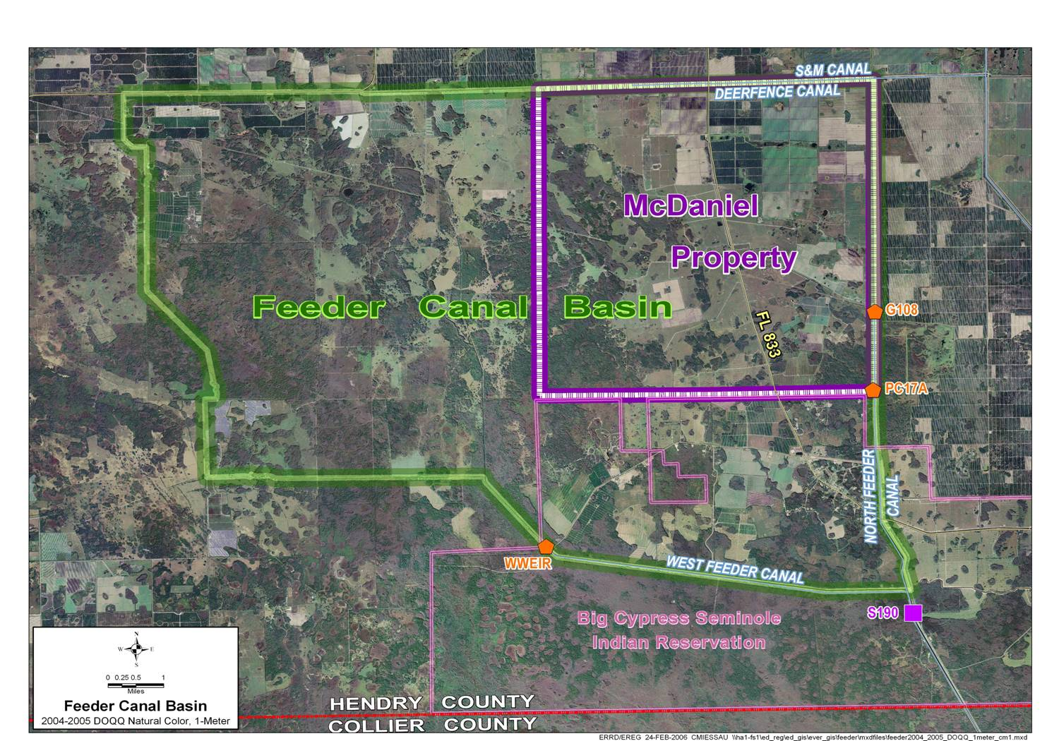

Figure 1. Feeder Canal Basin Map

The strategies recommended in the January 3, 2007, revision to the Long-Term Plan for the Feeder Canal Basin included (1) implementing major source control projects on the property known as McDaniel Ranch, (2) implementing a regulatory phosphorus source control program for the entire basin, and (3) providing additional funding in Fiscal Year (FY) 2007 through FY 2009 for the continued implementation of source controls beyond FY 2006. Also, the following two projects which were discussed in the October 27, 2003, Long-Term Plan continue to be other planned future projects that have the potential to significantly reduce the phosphorus load being generated by the Feeder Canal Basin: (1) a Central and South Florida Critical Restoration Project on the Big Cypress Seminole Indian Reservation, and (2) the Big Cypress/L-28 Interceptor Canal Modifications Comprehensive Everglades Restoration Plan (CERP) Project.

As recommended in the January 3, 2007, Long-Term Plan Revision, the District is taking steps to ensure that stormwater, from the property historically known as McDaniel Ranch, discharging through the structures PC-17A and G-108 (see Figure 1) meets a 50 parts per billion (ppb) flow-weighted mean (FWM) total phosphorus (TP) concentration resulting from a combination of Best Management Practices (BMPs) implementation and the construction of a stormwater management system, as described under the original ERP No. 26-00623-P (including timelines and monitoring requirements), issued on July 12, 2006. Additionally, in response to the increasing trend in TP concentrations in discharges from the Feeder Canal Basin, in early 2007 the District initiated implementation of a phosphorus source control program through an integrated regulatory compliance program applicable to all landowners throughout the basin. This program includes ensuring compliance with Environmental Resource Permits (ERP), Surface Water Management (SWM) permits, and Water Use Permits (WUP) and requiring implementation of BMPs). The program includes a methodology to measure its effectiveness in reducing phosphorus loads and concentrations to acceptable levels based on water quality monitoring results. The District will evaluate compliance with the FWM TP concentration of 50 ppb and the landowners’ proportional share of phosphorus load in discharges from the Feeder Canal Basin, based on monitoring results from the WWEIR, G-108 and PC-17A structures (see Figure 1). Compliance for Feeder Canal Basin landowners within the West Feeder Canal sub-basin (i.e., the areas within the Feeder Canal Basin west of the westernmost boundaries of the historic McDaniel Ranch property and the Big Cypress Seminole Indian Reservation) will be based on the WWEIR structure (see Figure 1) monitoring results. Compliance for the property historically known as McDaniel Ranch will continue to be based on the G-108 and PC-17A structures (see Figure 1) monitoring results. Any potential sheet flow between the McDaniel Ranch property and the West Feeder Canal sub-basin will be considered to have a negligible effect on water quality at the downstream structures (WWEIR, G-108 and PC-17A).
In order to insure the continued progress toward meeting the phosphorus reduction goals of the Long-Term Plan, the following revisions to the Long-Term Plan strategies for the Feeder Canal Basin are recommended:
- Initiate rulemaking for a Feeder Canal Basin BMP Program if after implementation of the projects and regulatory programs described above, water year (WY) results do not show TP concentration in discharges have achieved the 50 ppb concentration level.
- Provide additional funding of $150,000 per year for FYs 2009 and 2010 for implementation of source controls.

Summary Opinion of Cost and Expenditures (Part 3 of Long-Term Plan)

When the Long-Term Plan was developed in 2003, the 1994 Everglades Forever Act required Everglades Source Controls Program had already been underway for several years. Therefore, the Long-Term Plan recommendation for source controls funding included some limited additional funding to augment the Source Controls Program that was already underway. In order to more accurately represent the overall Everglades Sources Controls program being implemented in support of the Long-Term Plan, it is recommended that those costs be identified as part of the Long-Term Plan. The projected costs from FY 2008 through FY 2016 for the Everglades Source Controls Program are approximately $2.16 Million per year (in FY 2008 dollars). The proposed revision will allow the District to track costs for the Everglades Source Controls Programs and the supplemental source controls projects activities under a unified Long-Term Plan accounting and reporting code.

Proposed Revisions to Downstream Monitoring Project in Part 7 of Long-Term Plan:
This project is part of the “Recovery of Impacted Areas within the EPA” component (Part 7) of the Long-Term Plan. As recommended in the October 27, 2003, Long-Term Plan, monitoring in the impacted areas downstream of the STA discharges was conducted over FY 2004, 2005 and 2006. This monitoring was a continuation of the transect monitoring that was incorporated into the Section 404 permit associated with the construction and operation of the Everglades Construction Project Stormwater Treatment Areas (STAs). The objective of the downstream monitoring effort has been to assess the impacts (positive or negative) of STA discharges on the downstream receiving areas of the Water Conservation Areas (WCAs). As envisioned in the Long-Term Plan, the monitoring data was also intended to help in the development and calibration of a recovery model for the Everglades, therefore, all data collected pursuant to this project was provided to District staff working on the development of the recovery model. In order to fulfill the requirement to assess the impacts of the STA discharges on the receiving areas, in FY 2007, District staff performed an exhaustive review and analysis of the soils data, water quality data, and periphyton data that had been collected in the downstream areas in both the pre-STA-2 discharge and post-STA-2 discharge timeframes. A report summarizing this effort was drafted and is currently being finalized in preparation for a formal peer-review process. Initial results indicate that there have been improvements at several previously impacted sites and there has been generally no negative impact at previously unimpacted sites in WCA-2A resulting from STA-2 discharges. The positive impacts include increased hydroperiod and hydropattern, decreased surface water TP, steady soil TP concentrations, increased relative abundances of low nutrient periphyton indicator species, decreased relative abundances of high nutrient periphyton indicator species, and decreased nutrient content in periphyton tissues. T o further evaluate the trend in ecological conditions in the downstream area, it is recommended to continue the transect monitoring at sites that will augment those being incorporated into the long-term compliance permit for STA-2, and the data being collected as part of the Soil Reflux Study described in item 3.0 below.

The current proposed revision is to add three years of monitoring (ending in FY 2009) to the Downstream Monitoring Project. Costs to date for the Downstream Monitoring Project have been approximately $750,000, well below the original recommended budget of $1.5 million as described in the 2003 Long-Term Plan. The total estimated costs for the three additional years of monitoring are $500,000, therefore, no additional funding is proposed as a result of the latest proposed revision to add three years of monitoring to this project.

Proposed Revisions to the Determine the Relationship between Discharges to and Water Quality within the Everglades Protection Area Project in Part 5 of the Long-Term Plan:
This project fulfills a requirement of the Everglades Forever Act (Section 2.(4).e.3&4) and is part of the Process Development and Engineering (PDE) component of the Long-Term Plan. In the October 27, 2003, Long-Term Plan, this project was recommended to start in FY 2004 and to be completed in FY 2005, however, initial efforts to determine the relationship between discharges to and water quality within the Everglades Protection Area (EPA) were not successful using the data available at the time of the analyses. As a result, in 2006, the District requested and received approval for a Long-Term Plan revision to extend the completion date for this project by two years (from FY 2005 to FY 2007) to allow additional time to collect and analyze the data needed to determine the discharge relationship. In the 2006 Long-Term Plan revision, the District committed to providing funding for the Soil Reflux Study project being conducted by the Community Watershed Fund in the amount of $100,000 in FY 2006 and $50,000 in FY 2007. The intent of the revision was to use the results of the Soil Reflux Study to help determine the discharge relationship. Subsequent to the 2006 Long-Term Plan revision approval for this project, the Soil Reflux Study schedule was extended to May 2009 due to the 2006/2007 drought. As a result of the extension to the schedule for the Soil Reflux Study, and to allow incorporation of additional downstream monitoring data described in item 2.0 above, the completion date for the Determine the Relationship project is now proposed to be extended by three years, i.e., completion in FY 2010. Costs to date for this project have been approximately $200,000 which is well below the currently approved funding amount of $550,000. The total estimated costs to complete this project over FY 2008, 2009 and 2010 are $350,000, therefore, no additional funding is proposed as a result of the latest proposed revision.

