M E M O R A N D U M

TO: John Mitnik, Division Director, Operations, Engineering, and Construction
THROUGH: Peter Kwiatkowski, Section Administrator, Resource Evaluation
FROM: SFWMD Staff Water Supply Advisory Team
DATE: April 16th, 2019
SUBJECT: Water Supply Report

District-wide Conditions
Surface and groundwater levels showed mixed trends throughout the District over the last week. The majority of the United States Geological Survey (USGS) real-time wells in the Kissimmee Basin (KB) within the District boundaries are at medians levels for this time of year. Approximately three quarters of the surface water and groundwater stations across the KB recorded decreases in water levels over the last week. Stages in the Upper East Coast (UEC) canals C-23, C-24, and C-25 are at 21.84, 19.53, and 18.98 feet, all above the fourteen feet agricultural cut-off. Most stations are at median levels in the UEC. Surface and groundwater levels decreased in over half of the Lower East Coast (LEC) stations over the past week. The vast majority of the Biscayne aquifer monitor wells are at median levels and the upper percentile ranges for this time of year. Surface water levels are low in Everglades National Park.
Groundwater levels decreased in over half of the stations in the Lower West Coast (LWC) over the last seven days. Approximately twenty percent of the wells in the Surficial aquifer are in the upper percentile ranges, with the remainder at median levels. About seventy percent of the Lower Tamiami aquifer wells are at median levels, with the remainder in the upper percentile ranges. Approximately sixty percent of the Sandstone aquifer monitor wells are at median levels, with the remainder split between the upper and lower percentile ranges. About sixty percent of the Mid-Hawthorn aquifer monitor wells are in the lower percentile ranges, with the remainder in the upper percentile ranges. Figure 1 summarizes current water level conditions.

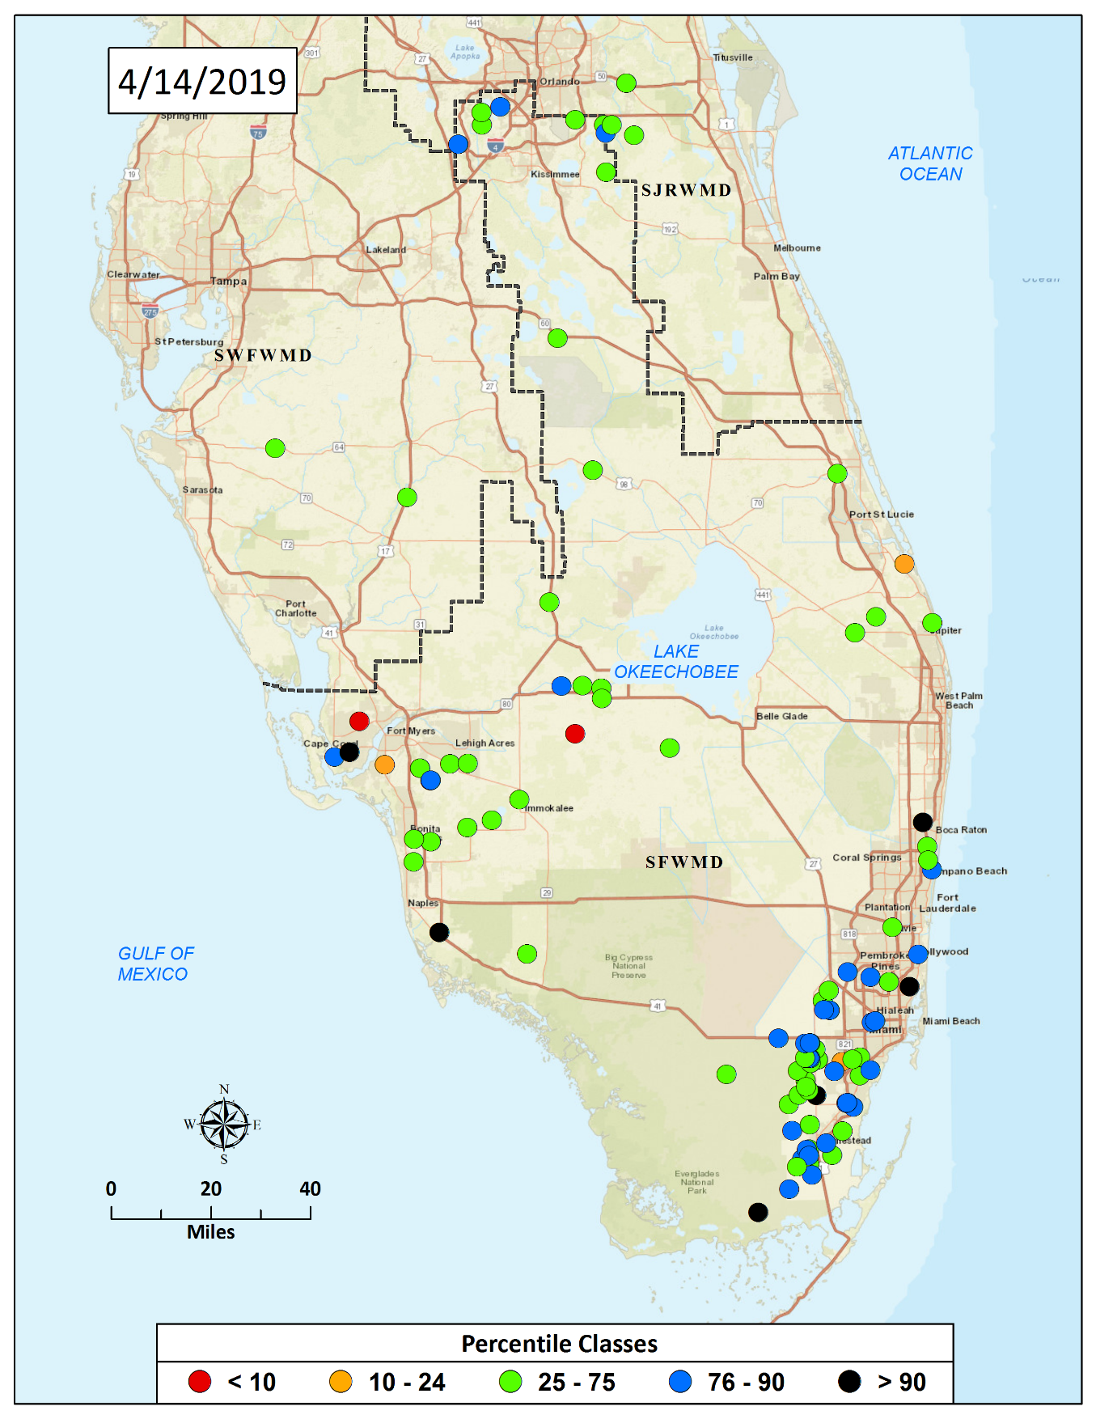

Figure 1. Real-Time Groundwater Level Map

Water Supply Technical Input to LORS2008
The Palmer Index for Lake Okeechobee (LOK) Tributary Conditions is -0.94 classified as “normal,” and is in the “low” risk category. The LOK stage for the next two months is projected to be in the Beneficial Use Sub Band, and the risk to water supply is categorized as “high.” The Climate Prediction Center’s (CPC) Precipitation Outlook is projected as “above normal” for one month and “above normal” for three months, leaving both the one-month outlook and three-month outlook in the “low” risk category. The LOK Seasonal Net Inflow Forecast is in the “normal to extremely wet” range, with “low” risk to water supply. The Multi-Seasonal Net Inflow Forecast is projected as “normal” with “moderate” risk to water supply. The stages in all Water Conservation Areas are above line 1 and in the “low” risk category. Year-Round Irrigation Rule is in effect for the LEC Service Areas. Figure 2 summarizes the water supply risk indicators.
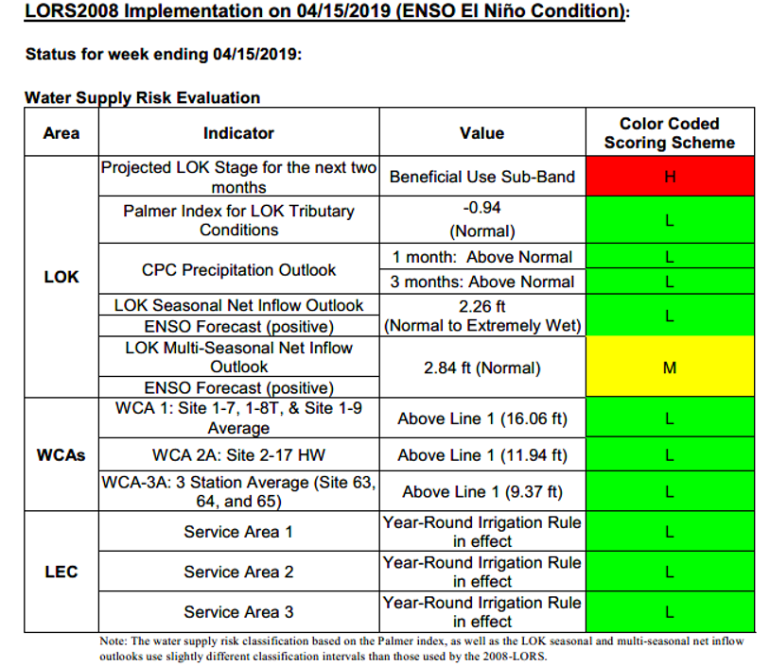
Figure 2. Water Supply Risk Indicators

