Nathan Kennedy
Exhibit 1 NRE Consulting Services, LLC
December 18, 2020

Assessment of the Everglades Agricultural Area Reservoir

Statement of Estimated Regulatory Costs

This report, done in coordination with the South Florida Water Management District staff, is intended to document an assessment of the potential regulatory costs and economic impacts of the proposed reservation rule last revised and adopted by the District on December 10, 2020. An earlier version of the rule was published on October 16, 2020. Subsequently, lower cost regulatory alternatives (LCRAs) where received from the City of West Palm Beach and stakeholders within the Everglades Agricultural Area. The latest version of the rule was developed in response to comments received from the public, and a public rule adoption hearing was held on December 10, 2020. While the revised rule language has addressed stakeholder concerns, some aspects of the submitted LCRAs are considered in the analysis below. The proposed reservation rule is examined considering its potential effect on the economy, business competitiveness, and regulatory costs covering all components of the Office of Fiscal Accountability and Regulatory Reform (OFARR) Statement of Estimated Regulatory Cost (SERC) form.
Proposed Rule and Economic Impact
The proposed reservation rule would reserve for the protection of fish and wildlife all surface water flowing out of the EAA Reservoir through Structures S-624, S-625, and S-626 toward protected basins within the Central Everglades. It is not likely to have any adverse impact on economic growth, private-sector job creation or employment, or private-sector investment within five years after the implementation of the rule. The lack of negative economic impacts is due to a scheduled revision of the reservation once a Project Operating Manual is developed for the EAA Reservoir and the reservoir is deemed operational by the District’s Governing Board, negligible future impacts on agricultural activities immediately adjacent to the reservoir, with no reduction of water supplies and flood protection services to entities upstream and downstream of the reservoir and the reserved water.

The proposed rule language under 40E-10.061 states:
Within 90 days of approval of the Final Project Operating Manual or Final System Operating Manual for the EAA Reservoir, the District shall publish a Notice of Rule Development to revise the reservation contained in paragraph 40E- 10.061(3)(a), F.A.C., above, and criteria in Section 3.11.6 of the Applicant’s Handbook, incorporated by reference in Rule 40E-2.091, F.A.C. Said rulemaking must result in an adopted rule that is in effect, unless subject to legal proceedings or legislative ratification, within two years of publication of the Notice of Rule Development and before the EAA Reservoir is deemed operational pursuant to paragraph 40E-10.061(3)(b), F.A.C., above.
No water will be reserved until the EAA Reservoir is constructed and deemed operational, and as stated above, the District shall revise the reservation prior to the reservoir being deemed operational. Therefore, the proposed rule operates as a prospective reservation. With no water being reserved, there are no negative economic impacts.
In the case that the rule was not prospective and did reserve actual water, the potential economic impacts to agricultural operations immediately adjacent to the reservoir were evaluated in the Technical Document to Support the Central Everglades Planning Project Everglades Agricultural Area Reservoir Water Reservation (SFWMD 2020). The technical document identified seven agricultural operations north of the reservoir permitted to use solely surface water from either the L-19, L-23, or the L-24 canals. Several modeling scenarios were performed to evaluate any potential seepage from the EAA Reservoir or reserved waters. Active management modeling scenarios indicate seepage can be fully captured, mitigating any potential seepage impacts.
Once the EAA Reservoir is operational with reserved water discharged through the S-624, S-625, and S-626 structures, there would be no change or shift in the sources of water available to existing legal users, and there would be no constraint on supplies for potential new consumptive uses. Upstream of the reservoir, the current water supply level of service for the Lake Okeechobee Service Area (LOSA) would be preserved through implementation of the project and would not be changed by the water reservation. Downstream of the reservoir, water exiting the structures identified above would immediately be discharged to protected basins within the Central Everglades. Water within these waterbodies is already protected from consumptive uses under the Lower East Coast Regional Water Availability Rule contained in Subsection 3.2.1.E of the Applicant’s Handbook for Water Use Permit Applications in the South Florida Water Management District (SFWMD 2015).
While no negative economic impacts of the proposed rule have been identified, the environmental affects of EAA Reservoir and its proposed reservation rule will result in substantial economic benefits for the local and regional economy. The EAA Reservoir will store regulatory releases from Lake Okeechobee and EAA basin runoff, thereby substantially decreasing the frequency and intensity of harmful discharges to the northern estuaries (St. Lucie and Caloosahatchee Estuaries). The EAA Reservoir will also deliver an average annual flow of 370,000 acre-feet above the existing flows to the Central Everglades, benefiting fish and wildlife. The increased water flows to the Central Everglades are essential to meet the restoration goals described in the Comprehensive Everglades Restoration Plan (CERP). It will also enhance regional water supplies for existing legal users, which in turn, will increase the amount of water available to meet environmental needs. The proposed water reservation rule will protect the water needed for fish and wildlife as required by CERP. A study published in 2014 in the journal of Ecological Economics (Richardson et al., 2014) assessed the potential economic value of the ecosystem services of the Central Everglades Planning Project (CEPP) of CERP, of which the EAA Reservoir is a principle component. The potential future benefits of CEPP were estimated to be approximately $1.8 billion. This estimate was only for a subset of the total array of ecosystem services that will be provided by the EAA Reservoir, its proposed rule, and CEPP. The total economic value to society is likely much greater than the $1.8 billion identified in this study.
Number of Individuals and Entities Required to Comply
No individuals or entities will be required to comply with the proposed rule because of its prospective nature as described above. Furthermore, when the EAA reservoir is operational, all reserved water will be discharged directly to protected basins and would be protected by existing regulations.
Stakeholders who submitted LCRAs expressed concerns that the earlier version of the rule published on October 16, 2020 would affect individuals and entities within LOSA and the Lower East Coast (LEC). The revised rule has addressed these concerns, but an analysis of the recent trends in surface water permitting in these areas was still completed. From 2015 to 2020, the District received 81 permit applications for increases in surface water sources subject to the LOSA Rule (figure 1). From 2015 to 2020, the District received 365 permit applications within the LEC (figure 2). Of the 365 received, none of the applicants sought increases in direct surface water or indirect groundwater allocation without also identifying acceptable sources to meet those increased withdrawals.
Costs to the District and to any Other Local Government Entities
The proposed reservation rules do not impose additional regulatory requirements or penalties that must be enforced by the District. If any costs arise as a result of the prospective reservation, the District intends to implement the proposed reservation rule within its current workload and with existing staff. The proposed rule will not affect and other government entities.
Transactional Costs of Proposed Rule
No new transactional costs are anticipated from the proposed rule. The proposed EAA rule amendment does not require existing permittees to renew their permits or meet any additional criteria to renew their consumptive use permits, nor require applicants requesting new volumes of water to perform any additional analyses or meet any additional criteria to obtain their consumptive use permits.
Impact on Small Businesses, Small Cities and Small Counties
No small businesses, small cities, or small counties will be negatively affected by the proposed rule.
References
Richardson, Leslie & Keefe, Kelly & Huber, Christopher & Racevskis, Laila & Reynolds, Gregg & Thourot, Scott & Miller, Ian, 2014. "Assessing the value of the Central Everglades Planning Project (CEPP) in Everglades restoration: An ecosystem service approach," Ecological Economics, Elsevier, vol. 107(C), pages 366-377.
SFWMD. 2015. Applicant’s Handbook for Water Use Permit Applications within the South Florida Water Management District. South Florida Water Management District, West Palm Beach, FL. September 7, 2015.
SFWMD. 2020. Technical Document to Support the Central Everglades Planning Project Everglades Agricultural Area Reservoir Water Reservation, Final Report, September 2020. South Florida Water Management District, West Palm Beach, FL.

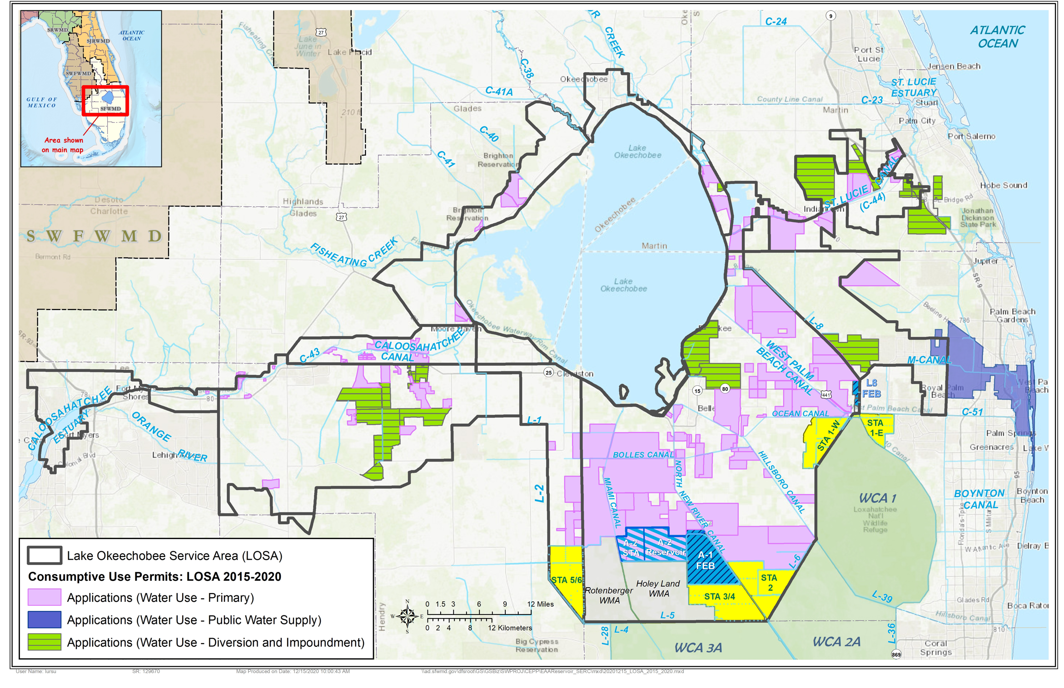
Figure 1: LOSA Permit Applications 2015-2020
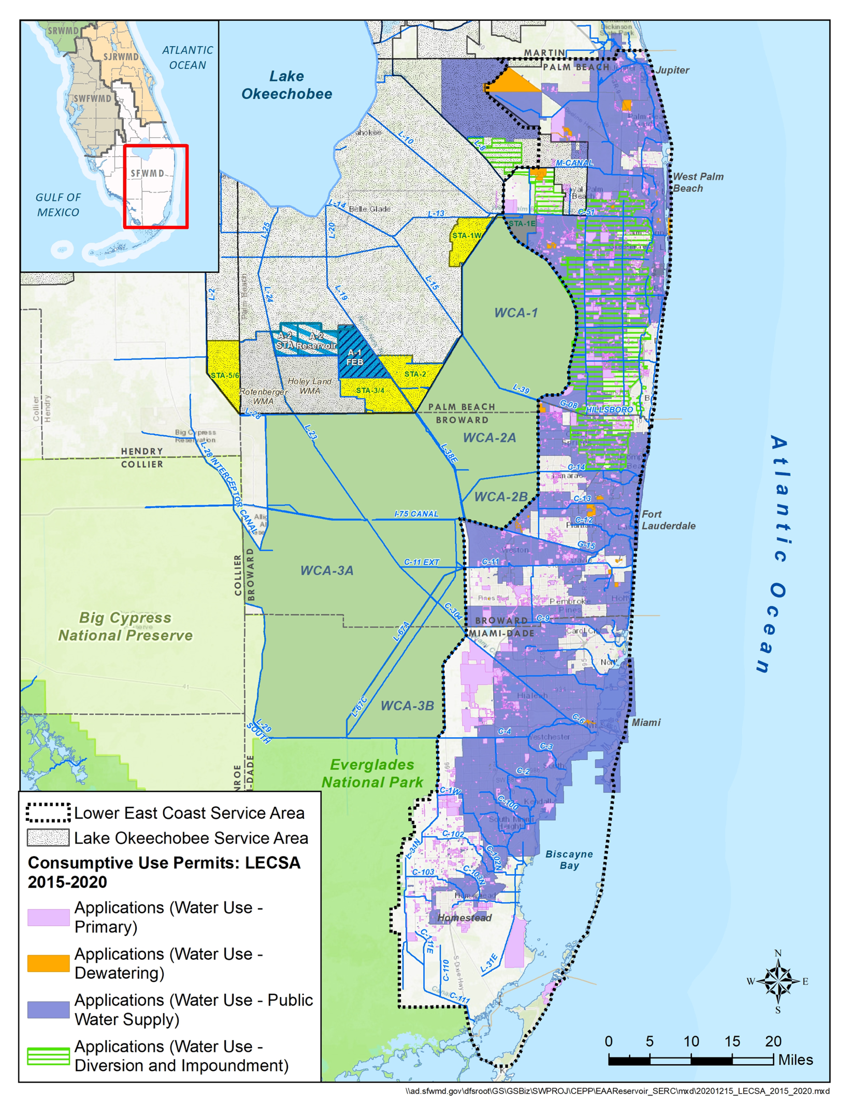
Figure 2: LEC Permit Applications 2015-2020

